November 21, 2024

Foundation for the Advancement of Health Education
Scholarship Review Committee
Becky J. Smith Scholarship

To the Review Committee,

I am pleased to submit a letter of reference for the scholarship application of Caitlin Olafsson for the Becky J. Smith Scholarship. Caitlin is an exceptional student, and per FAHE request, I verify she meets all the academic criteria for the award related to class standing, GPA, and major.

I have known Cait for most of her time at Gustavus and am happy to share some about her. She has taken several courses with me and is an advisee. As an indicator of her drive, up until this last month Gustavus did not have a major in public health education. Knowing this was the direction she wanted to pursue, Cait came to me, and we designed an individualized major that would not only allow her to be employed in public health but would allow her to sit for the CHES exam when she completes her degree in 2026. The process is complicated and time consuming but her drive to enter the field is strong, she has made the commitment, and she will graduate with a degree in public health education.

Over the time she has been taking courses in public health, Cait has shown the same level of determination to learn and succeed. She is interested in more than just good grades…she wants to learn background, context, and application. She is trying to see the big picture as she prepares to enter the field. In fact, she voluntarily stepped into a role with our local County Health Assessment team to gain greater experience at that level. She is strong as both a contributor and leader and is an ambassador for public health education on our campus. She is inquisitive and dedicated, just what we want to see in the future of health education.

In short, I believe Cait is an excellent candidate to receive this scholarship and I hope the committee gives her strong consideration. I there are further questions, do not hesitate to contact me.

Sincerely,
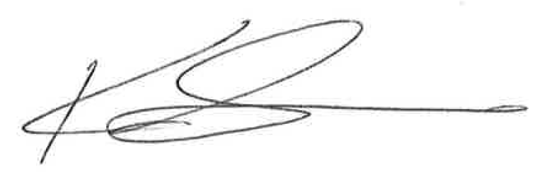
Karl Larson, Ph.D.
Professor and Program Director, Public Health

