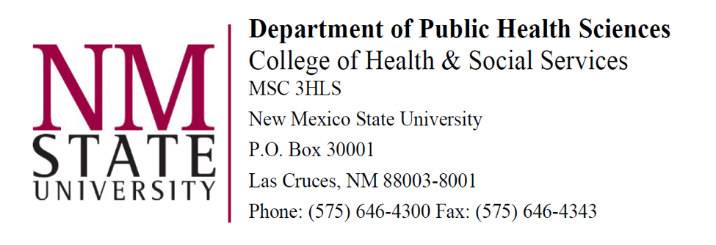

May 27, 2024

Dear Members of the Dr. Mary K. Beyrer Graduate Student Scholarship Selection Committee;

I am writing this letter to very highly recommend Chinenye Onyeanwu for FAHE’s prestigious Dr. Mary K. Beyrer Graduate Student Scholarship. I have known Chinenye for approximately one year, since she approached me about a research project on elders experiencing homelessness and applying to the Public Health Sciences PhD program. She began working on this project immediately, and subsequently was accepted into the department’s PhD in Health Equity Sciences with a focus on health and nutrition education and relevant policy. She is currently enrolled in her first semester in our program and is earning A’s in all her classes. In her previous Masters of Science in Human Nutrition, she earned a 4.92 GPA on a scale of 5.00. I am her faculty mentor in our Healthy Equity Sciences program.

Chinenye is conscientious and devoted to supporting the health of people who both have been marginalized and are struggling with their health. She is particularly interested in nutrition as a key to health, and has already completed a Bachelor of Science degree in Nutrition and Dietetics, an RD Degree with a Dietetic Internship, and Masters of Science degrees in Human Nutrition and Molecular Biology. She is especially well prepared to create nutrition education programs and impact policy creation and implementation that will affect the long-term health of elders who are experiencing homelessness and living in situations of deep poverty.

Chinenye has had the experience with community service and health education to know that she wants these aspects of public health to be cornerstones of her future career. Her work before entering NMSU was with youth and elders. While working on an MSc degree in Sweden, she spent two years as a volunteer teaching mathematics to immigrant youth, aged 10-16. Before this, she provided nutrition education to elders in Nigeria, and mathematics education to primary and high school students in Nigeria. Even though she is still in her first semester of our PhD program, she has begun volunteering with a local organization called “Brighter Bites.” The program promotes nutrition education and access to fresh produce in Las Cruces Public Schools. It is currently implementing a nutrition curriculum in six Las Cruces Public School System schools through which it is also providing up to 20 pounds of produce to families each week. Although this is not the population Chinenye ultimately will focus on for her dissertation work, this is a population with a similar level of need for resources and health education. Working with them provides Chinenye with an important opportunity to connect with the network of nutrition education and food distribution programs and service providers, which she will need moving forward.

As an international student from Ghana, Chinenye is not eligible for some forms of funding in the US and so has already been having financial difficulties that have distracted her focus. The honorarium associated with this scholarship would help her tremendously in making ends meet, buying school supplies such as books, and presenting at local conferences, such as the New Mexico Public Health Association Conference in the spring.

Overall, Chinenye is mature, self-assured, and well-prepared to begin her program of study. She is interested in community-based health education and wants to provide the best learning environment possible for her future students. She has the necessary knowledge, experience, determination and perseverance to succeed. The support for her scholarship that the Dr. Mary K. Beyrer Graduate Student Scholarship would provide would enable her to focus on continuing to build her community network and on her PhD coursework. Thank you for your consideration. Please feel free to contact me if you have any questions or need any additional information.

Elizabeth S. England-Kennedy, PhD, MPH, CHES

Assistant Professor, Public Health Sciences Department
College of Health, Education, and Social Transformation
1335 International Mall
Room 327
PO Box 3001 MSC 3HLS
Las Cruces, NM 88003-8001
eengken@nmsu.edu

