
BROOKS COLLEGE OF HEALTH
1 UNF Drive
Jacksonville, FL 32224-2673
(904) 620-2840 Fax (904) 620-1035
________________________________________________________________________________________________________________
Department of Public Health

November 25, 2023

Dear Review Board,

It is with enthusiasm that I provide this letter strongly supporting Ja’Nya Johnson’s application to the Dr. Mary K. Beyrer Graduate Student Scholarship. As a faculty member and Program Director of the Master of Public Health program at UNF, I have had the privilege of working closely with Ja’Nya. She is a competent, dedicated, and genuinely personable individual who I believe will be very successful in both her academic and professional careers. I am familiar with her work, and thus believe she is most deserving of this prestigious award.

Ja’Nya’s academic accomplishments are outstanding. She is among the top 10% of students I have worked with in my 20 years of higher education, academically, professionally, and personally. She is intuitive, determined, goal driven, and hard working. Her reliable level of quality work and meaningful involvement are admirable. One of her greatest strengths as a health education professional is her ability to discover new findings in research and apply them to public health concerns in different populations. She is a natural writer and wrote her first book, "Functioning in Dysfunction" in 2021. In this book, Ja’Nya explains her rare diagnosis and how she was able to find the solution through research. She has also published an article, "Childhood Behaviors often Lead to Adult Consequences" by the Florida Times Union. Most recently, Ja’Nya was unanimously selected by the MPH faculty to represent our graduate program at various events throughout the year as an MPH Ambassador.

Ja’Nya has had several experiences that continue to shape her success in the health education field. Before beginning her MPH, she worked as a Certified Nursing Assistant at UF Shands in the trauma unit. She then transitioned into Behavioral Health at Memorial hospital where she cared for mentally ill and substance use patients. It was here when she gained insight for the need for care beyond the bedside. This perspective led her to obtaining a BS in public health, and currently to her MPH. Ja’Nya has also gained experience coordinating health events as a member of Eta Sigma Gamma (ESG) at UNF.

During the time I have known and worked closely with Ja’Nya, I have developed great admiration for her talents, professionalism, and unsurpassed efforts. She is the type of person you want to work with: very positive, committed and capable. She has been a fantastic addition to the Public Health Department, UNF, and the community. Thank you for your time and consideration.

Sincerely,
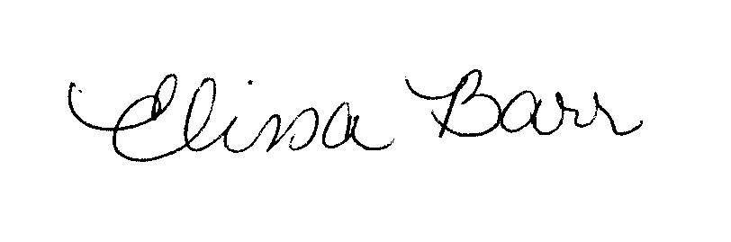
Elissa M. Barr, PhD
Professor of Public Health
ebarr@unf.edu

