Health Education Leadership/ Advocacy/ Service
Eta Sigma Gamma Health Education Honorary Society: I am the social events coordinator for UNFs ESG public health society. I am also the secretary for the team as well, we promote health and wellness around campus to achieve optimal health in college students.
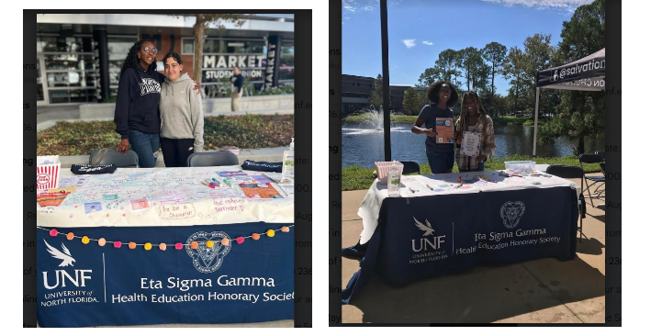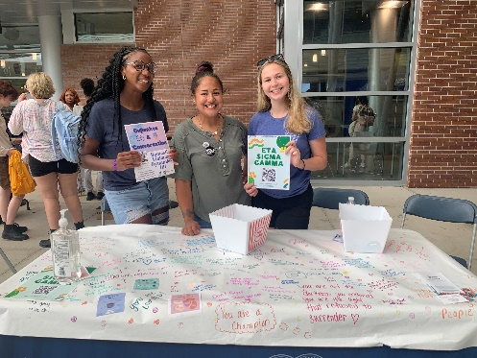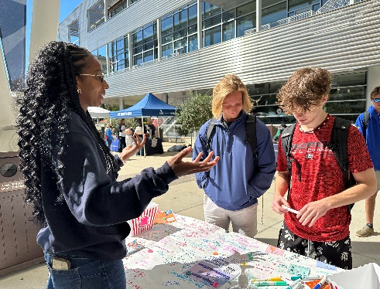
I wrote my first book revealing a rare health diagnosis and how I utilized research to discover the diagnosis and treatment to improve my health. I have shared my book with others to teach them how to advocate for their health and happiness.
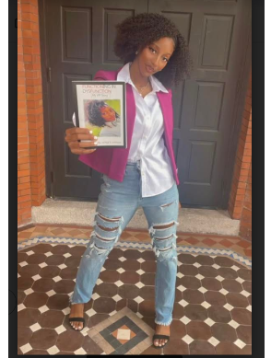
I serve as a youth minister at Zion Community Church.
