

Committee Members

Annual Awards Committee  
 Foundation for the Advancement of Health Education

Dear Review Committee Members:

# I am pleased to write this letter in support of Ms. Lindsay Keeling’s application for the prestigious Dr. Mary K. Beyrer Graduate Student Scholarship. Lindsay is a full-time MPH/MSW Dual Major student at New Mexico State University and meets the eligibility requirements for this scholarship. I serve as the official advisor for Lindsay, work with her on academic coursework, and can attest that she has high academic grades (GPA>3.5) and has profound involvement in the profession of public health education. Based on my experience working with her, I can easily rate her among the top 1% of students I have mentored in the past decade. She is nationally at par with the best and this scholarship will be a fitting testimony to her hard work, dedication, and accomplishments in the field of public health and social work.

# Lindsay has keen interests in the field of public health as reflected in her resume. She has served in multiple leadership and service roles to improve knowledge and education of the most marginalized communities and groups across the world. Her current educational and professional endeavors focus on homeless populations, prisoners, and children who have experienced adverse childhood events. Since starting her rigorous graduate education in public health and social work, she has quickly established herself as a dependable colleague and collaborator. She is working on multiple projects with faculty across multiple disciplines on projects addressing health issues of vulnerable families, vaccination hesitancy, health behaviors of displaced and incarcerated populations, just to name a few. Within the past year, she has grown leaps and bounds as a researcher and acquired numerous skills on social and behavioral research, ethics and conflict management, and human subject’s protection. She is working with diverse populations with multiple community networks. As a result of her hard work and accomplishments, she has won numerous honors from regional and national agencies. After graduating in Spring 2023, Lindsay plans to pursue her doctoral education in health education and health promotion. The prestigious Dr. Mary K. Beyrer Graduate Student Scholarship will further her interests and be of great support as she continues with her challenging moves and takes on difficult tasks in our communities to ensure that people are empowered and healthy.

# I could not think of a better candidate to be nominated than Ms. Lindsay Keeling for the esteemed Dr. Mary K. Beyrer Graduate Student Scholarship. She is very committed to the purpose and enterprise of public health education and will certainly become a prominent educator, scholar, and practitioner in the near future for our field of public health education. I remain committed to providing her all the resources for a fulfilling career in the field of public health education. She will represent the legacy of Dr. Mary K. Beyrer Graduate Student Scholarship with honor and distinction befitting this worthy opportunity. She has my highest recommendation and please do not hesitate to reach out if I can provide additional details about Ms. Lindsay Keeling’s skills and qualifications. Thank you again for considering this letter of support.

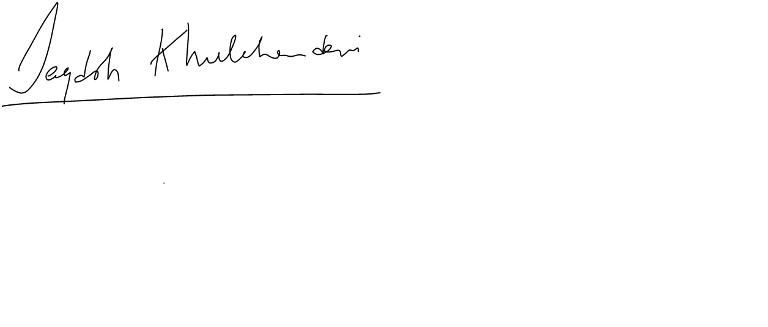

Jagdish Khubchandani, MPH, PhD  
Public Health Sciences  
New Mexico State University   
Email: [jagdish@nmsu.edu](mailto:jagdish@nmsu.edu)