November 5, 2021
Statement of Development and Change

Dear Foundation for the Advancement of Health Education,

The Hawaiʻi Good Food Alliance (HGFA) is committed to re-building thriving community food systems for the purpose of food justice and health equity for each and every person in Hawai‘i. Starting as a small pilot project, we evolved into a statewide coalition of volunteers that further evolved into an effective, organized nonprofit. We acquired 501c3 status in 2020, and now are engaged in numerous collaborative efforts to effect meaningful change toward equity and justice in food and health:
- Awarded a $750,000 foundation grant to establish our organization structure and build capacity
- Established a Board of Directors, chaired by Tina Tamai, (with advisors: Fair Food Network, Shift Health Accelerator, Hawaiʻi Investment Ready) to extend impact while maintaining a culture of shared leadership, collaboration, and community-led systems change.
- Staffing (Executive Director and Administrative Assistant) to manage and elevate HGFA operations and work
- Funded initiatives in the following areas:
- Whole Community Evaluation Framework (in partnership with the University of Hawaiʻi Department of Human Nutrition and School of Medicine) – development of an innovative rubric which reflects food as an impact on all sectors of life
- Hawaiʻi Food Hub Hui (Group) – to strengthen and connect Hawaiʻi’s food hubs to support local producers while increasing equitable distribution to communities statewide
- Food As Medicine (in partnership with the Waianae Coast Comprehensive Health Center, Hawaiʻi Pacific Health Systems, HMSA, University of Hawaii School of Medicine) – integrate food as the foundation for health in community health center as well as traditional healthcare and health insurance systems
- Hawaiʻi Good Food Fund (in partnership with Hawaiʻi Investment Ready) – to increase access to capital for community-based, equity-oriented food systems enterprises.
- Implementation of a $5 million USDA GUSNIP “Double Bucks” healthy food incentives for SNAP participants statewide, and a $407K USDA FMPP grant to establish a statewide Farmers Market Association.
- Recently awarded a $829K USDA RFSP grant to strengthen and connect 12 food hubs to support local producers and increase equitable distribution to communities statewide.
- Continued search for innovative ways to raise money to strengthen food systems by working with numerous partners, including the Hawaiʻi Food and Farm Funders Hui.

Our purpose is to coordinate initiatives to transform Hawaiʻi’s food systems to increase equitable access and improve health for all in Hawaiʻi. We have laid the foundation for future activities.

Sincerely,
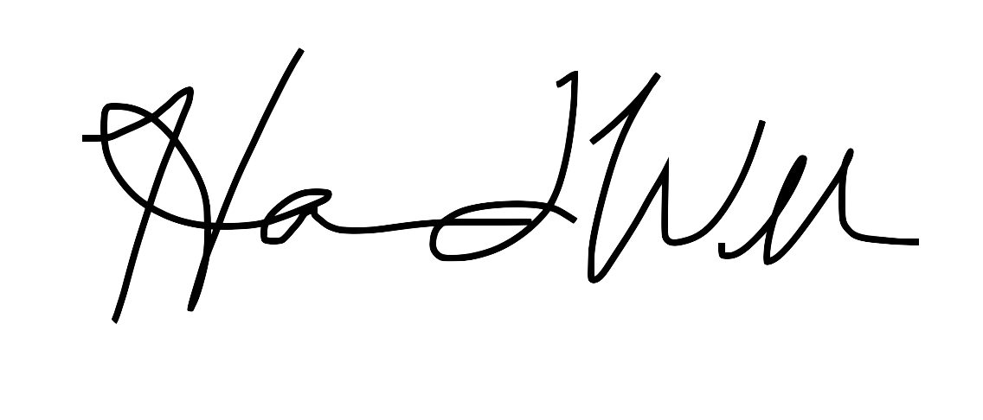
Harmonee Williams, Executive Director
https://hawaiigoodfoodalliance.org/

