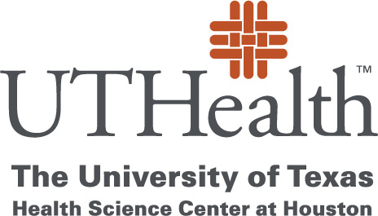

**School of Public Health**

October 30, 2021

Dear Colleague,

I am pleased to write a Letter of Recommendation for Ms. Brittany Jones. I have known Brittany since she was admitted into our Dietetic Internship, which is housed under the department of Health Promotions/Health Education in April 2020. I am both her Dietetic Internship Director and mentor.

She presented as an extremely strong student, and her current academics reflects this very high standard. I have had the opportunity to work with Brittany on many projects through our new resources, and she has an extraordinary work ethic and takes the role of a leader seriously.

This ability is the result of her dedication, hard work, and motivation in the field of Nutrition and Dietetics. She is passionate about her field and every project she undertakes. I am impressed with her ability to adapt to this program, working with diverse populations and being extremely open to every opportunity presented to her.

Brittany has already demonstrated her passion for her future career in the field of dietetics. She has worked as a Graduate Assistant in both Culinary Medicine and our Garden for Health Courses. She demonstrates a maturity level that is often not achieved until later in a student’s rotations. She has insight to the profession that comes from working in the field and realizing that the field of nutrition is always evolving and not a finite science.

She has an amazing talent to inspire, lead, and educate. She is reliable, self-directed, and responsible. She excels at detailed oriented tasks, time management, and applying her knowledge of nutrition. She is committed to excelling in her field.

Brittany would be an outstanding candidate for the Dr. Mary K. Beyrer Graduate Student Scholarship. I am confident that she will continue to be successful in her career and future academic endeavors. It is without reservation that I can recommend her.

Sincerely,

Jeanne M. Piga-Plunkett MS RD LD

Jeanne M. Piga-Plunkett Director of UTSPH Dietetic Internship