

11/8/2020

To the Dr. Delbert Oberteuffer Scholarship Selection Committee:

Please accept this letter of reference for Ms. Michelle Strong’s application for the Dr. Delbert Oberteuffer Scholarship. I am an Assistant Professor in the Department of Health and Kinesiology at Texas A&M University in College Station and have worked with Ms. Strong over the past year through coursework, directed studies, and now as a member of her dissertation committee. Few students are as impassioned and driven as Ms. Strong, and I therefore have no hesitation in providing an enthusiastic recommendation for her selection as a Dr. Delbert Oberteuffer Scholarship awardee.

In reflecting on why I believe Ms. Strong is a worthy recipient of this award, the first word that comes to mind is *resilience.* I have yet to see a barrier or obstacle keep Ms. Strong from reaching her goals – she strives for excellence no matter what she has to work through. For example, over the past year Ms. Strong has taken two of my graduate level courses (Research Methods and Social Network Analysis) remotely due to obligations to her family in San Antonio (note: this was pre-COVID 19). Admittedly I was worried about her ability to keep up, engage, and excel in the classes given she “zoomed” in and completed her work independently. Let me just say, she absolutely quelled any worry I could have had. Not only was Ms. Strong an active participant and contributor in both classes, she was a standout – outperforming her peers. Additionally I have had the pleasure of collaborating with Ms. Strong on papers and presentations, as well as “dreaming” with her about research projects and ways she can apply the knowledge she has learned in my classes, especially using Social Network Analysis (my primary research area). I am motivated and inspired by her aspirations to do good, meaningful work. I truly believe this award could foster growth in Ms. Strong, and result in impactful contributions to the field of Health Education.

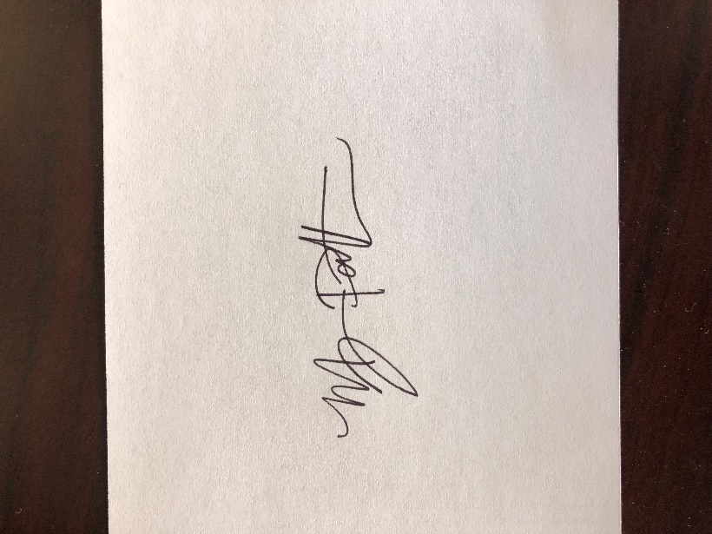In closing, I am honored to provide this reference letter for Ms. Michelle Strong. I am excited for her future and believe this scholarship will position her to succeed even more than she already has. If any questions arise, please do not hesitate to email me at megpatterson@tamu.edu, or phone at 817-909-0664.

Best Regards,

**Megan S. Patterson, PhD MPH**

Assistant Professor

Department of Health & Kinesiology

Texas A&M University