**Impact of pharmacy student-led teaching during a short-term medical mission trip to the Dominican Republic**

**Abstract:**

**Introduction**. Because pharmacy students are trained and well-equipped to provide impactful teaching, they present an opportunity to bridge the education gap on medical mission trips.

**Methods**. This was an observational study of an educational initiative to expand health professional knowledge through pharmacy student-led teaching on a Dominican Republic medical mission trip. Study participants received a 10 question multiple choice pre and post assessment.

**Results.** The difference in the means between the pre and post assessments was 1.45 questions (95 percent confidence interval, -2.03 to -0.88, P less than 0.05). The greatest increase in knowledge was observed with questions relating to antibiotic resistance, hypertension and diabetes.

**Discussion**. Pharmacy student-led teaching demonstrated an increase in health professional knowledge on a short-term medical mission trip.

**Introduction.** Student participation on a variety of global health initiatives has increased as much as 25% since the 1970’s.1  Pharmacists and pharmacy students have been regarded as important members of international medical mission trips by providing drug information knowledge, therapeutic interventions, and patient education.2-4  A review of global health education in the 133 United States doctor of pharmacy programs found that nearly 40% of programs offered global health education opportunities such as advanced pharmacy practice experiences in other countries or international medical mission trips.5

Maki and colleagues utilized an assessment tool for short-term international medical mission trips in order to identify areas of improvement. Education was by far the lowest score across mission trips, as it is often not a formal goal of the organizations. Only 60 percent of mission trips provided training or education to local healthcare professionals, presenting an area for further development.6

There is no available literature to support the use of student-led education on medical mission trips, however this teaching technique has proven to be effective in other settings.  Gottlieb and colleagues conducted a study evaluating the effectiveness of medical student peer education. Overall, 90 percent of second year medical students reported that fourth year medical student teachers increased their understanding of the material, and 92.4 percent reported the quality of the lecture to be similar or better than sessions taught by faculty members alone.7  Beggs and colleagues explored the effectiveness of pharmacy student-led teaching on primary care health topics in adults experiencing homelessness.  Survey results showed that the pharmacy student-led education increased participant’s perceived knowledge gained, although no data was collected as to the extent of this increase.8

The Accreditation Council for Pharmacy Education (ACPE) emphasizes that pharmacy students should have the capacity to counsel and educate all audiences on health topics through effective communication.9 Because pharmacy students are trained and well-equipped to provide impactful teaching, they present an opportunity to bridge the education gap on medical mission trips.  The objective of this study was to assess if pharmacy student-led education improves health professional knowledge on medical mission trips.

**Methods.** This was a prospective observational cohort study. Participants included doctors, medical residents, and nurses working in the Dominican Republic.  Education was provided by five students of an United States ACPE-accredited college of pharmacy on their advanced pharmacy practice experience as part of an international medical mission trip.  The verbal, case-based education covered four topics that were chosen based on input by the Dominican healthcare providers: antibiotic resistance, medication safety, hypertension, and diabetes.  A medical Spanish translator was used to interpret the presentation.

Study participants received a 10 question multiple choice pre and post assessment. Questions were written to equally represent material from the four topics that were covered throughout the educational initiative. The pre and post assessments were available with English on one side and Spanish on the other, as most of the participants spoke Spanish as their primary language.  Participants were asked to complete the pre assessment prior to the education and the identical post assessment after the completion of the education to evaluate knowledge gained. Assessments were graded with one point awarded for each correct answer, with a maximum possible score of 10.  This study was approved by the institutional review board of the college of pharmacy.

Categorical data is presented as frequencies and percentages. Continuous data is described using both mean and standard deviation (SD), as well as median and interquartile range (IQR). Average performance on pre and post assessments were analyzed using a paired sample T-test. Performance on each question was analyzed separately using a McNemars test. P-values of less than 0.05 were considered to be statistically significant.  Statistical analyses were conducted using Statistical Package for Social Sciences version 23.0 (SPSS, Inc., Chicago).

**Results.** A total of 22 participants completed both the pre and post assessments. As seen in Figure 1, the median score of the pre assessment was 6 (IQR 5 - 7.25), with a minimum score of 3 and maximum score of 8.  The median score of the post assessment increased to 8 (IQR 6.75 - 9), with a minimum score of 4 and maximum score of 10. The mean score on the pre assessment was 6.14 (+/- 1.52) questions answered correctly out of 10 possible, which increased to an average score of 7.59 (+/- 1.53) questions answered correctly on the post assessment. Mean total score was significantly improved from pre to post assessment. The difference in the means between the pre and post assessments was 1.45 questions, 95% CI [-2.03, -0.88], with a p-value of < 0.05.

The greatest increase in knowledge was observed with questions relating to antibiotic resistance, hypertension, and diabetes (Table 1). Question 1, regarding antibiotic resistance, showed a 27.3% (p=0.070) increase in participants with correct answers.  Question 6, regarding hypertension, had a statistically significant 36.4% (p=0.039) increase in the percentage of participants that answered the question correctly.  Question 9, regarding diabetes, had a statistically significant increase in participants answering correctly at 63.7% (p=0.000).  This increase was the largest, as only 1 of 22 participants answered question 9 correctly in the pre assessment and 15 of 22 participants answered correctly in the post assessment.  Other questions had more consistent results or low performance in both the pre assessment and the post assessment, however the value of the differences were not considered significant.  Overall, every question showed an equivalent or increased frequency of correct answers, except for question 3, where all 22 participants answered correctly when taking the pre assessment, yet one participant answered incorrectly on the post assessment.  This result, however, was not statistically significant.  

**Discussion.** Short-term medical mission trips are growing in popularity among healthcare students, providing an expanding scope of outreach for student-led teachings to other cultures and languages.  This method has been used by medical students and pharmacy students to increase the knowledge of those receiving instruction.  There is evidence to show that education is the least developed component of medical mission trips, therefore the success of this pharmacy student-led educational initiative presents an opportunity for this style of teaching to be applied on future medical mission trips. Incorporating this teaching technique into service trips can serve as a vessel to expose developing countries to current medical practices in order to reinforce optimal treatment recommendations and safe practices.

A previous study showed that pharmacy student-led teaching increased the perception of knowledge gained by participants, however no assessments were used to quantify specific knowledge gained. This study, in contrast, utilized pre and post assessments to show an increase in the average number of correct answers after the educational initiative compared to before, indicating an increase in knowledge attributed to the student-led teaching. The results showed that student-led teaching, even cross-culturally and through the use of translators, can be an effective addition to short-term medical mission trips.

Our data can also be used to assess the participant’s understanding of the topics discussed and where more education would be needed in the future.  At baseline, the participants seemed to know the least about the subjects of hypertension and diabetes.  After reviewing these disease states during the educational initiative, all questions regarding hypertension and diabetes showed an increase in the number of correct responses.  This shows that common best practices in the United States may not be as widely known in developing countries, presenting an opportunity for education to improve patient care and outcomes.  The subjects, such as medication safety, where the participants did not show as significant of an increase in knowledge give direction as to where future teachings in the area should focus.

There are several limitations to this study, including the small sample size. With an increased sample size, more results may have shown statistical significance. Additionally, the use of a translator presents the possibility of incomplete translation or misinterpretation between languages. Lastly, demographic data was not collected, therefore it is difficult to quantify knowledge gained based on specific healthcare profession.

In conclusion, on a short-term medical mission trip to the Dominican Republic, pharmacy student-led teaching demonstrated an increase in health professional knowledge.  Based on the findings of this study, short-term medical mission trips should include a student-led teaching component.  This innovative addition could benefit not only the students in their training to become competent healthcare providers, but also the providers, patients, and underserved communities that these medical mission trips serve.

**References**

1. Kao, J. The growth of medical student opportunities in global health. *MSRJ*. 2014;4:48-50. doi 10.3402/msrj.v3i0.201329.
2. Steeb DR, Joyner PU, Thakker DR. Exploring the role of the pharmacist in global health.  
   *J Am Pharm Assoc*. 2014;54(5):552-5.
3. Johnson CA1, Stieglitz N, Schroeder ME. Opportunities and responsibilities for pharmacists on short-term medical mission teams. *J Am Pharm Assoc*. 2009;49(6):801-7.
4. Clements JN, Rager ML, Vescovi EM. The value of pharmacy services on a short-term medical mission trip: description of services and assessment of team satisfaction. *Ann Pharmacother*. 2011;45(12):1576-81.
5. Bailey L, DiPietro Mager N. Global Health Education in Doctor of Pharmacy Programs.  *Am J Pharm Educ*. 2016;80(4):71.
6. Maki J, Qualls M, White B, Kleefield S, Crone R. Health impact assessment and short-term medical missions: A methods study to evaluate quality of care. *BMC Health Services Research.* 2008; 8:121.
7. Gottlieb Z, Epstein S, Richards J. Near-peer teaching programme for medical students. Clin Teach. 2016 Jun 20. doi: 10.1111/tct.12540.
8. Beggs AE, Karst AC. Effectiveness of Pharmacy Student-Led Health Education in Adults Experiencing Homelessness. *J Health Care Poor Underserved*. 2016;27(3):954-60.
9. Accreditation Council for Pharmacy Education (ACPE). Accreditation standards and key elements for the professional program in pharmacy leading to the Doctor of Pharmacy degree. Chicago, IL: ACPE, 2015. Available at: <https://www.acpe-accredit.org/pdf/Standards2016FINAL.pdf>.

**Figure 1. Comparing Pre and Post Assessment Medians**

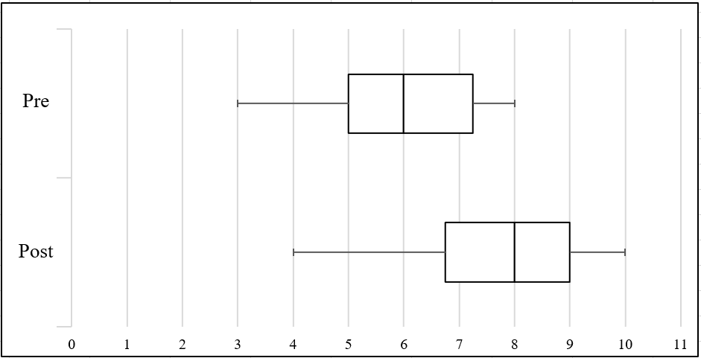

**Table 1.  Pre and Post Assessment Results**

|  |  |  |  |  |
| --- | --- | --- | --- | --- |
|  | Topic  Covered | Pre  no. (%) | Post  no. (%) | P-value |
|
| Question 1 | Antibiotic resistance | 12 (54.5) | 18 (81.8) | 0.070 |
| Question 2 | Antibiotic resistance | 19 (86.4) | 19 (86.4) | 1.000 |
| Question 3 | Medication safety | 22 (100) | 21 (95.5) | 1.000 |
| Question 4 | Medication safety | 17 (77.3) | 18 (81.8) | 1.000 |
| Question 5 | Hypertension | 20 (90.9) | 21 (95.5) | 1.000 |
| Question 6 | Hypertension | 9 (40.9) | 17 (77.3) | 0.039 |
| Question 7 | Hypertension | 16 (72.7) | 17 (77.3) | 1.000 |
| Question 8 | Diabetes | 13 (59.1) | 14 (63.6) | 1.000 |
| Question 9 | Diabetes | 1 (4.5) | 15 (68.2) | 0.000 |
| Question 10 | Diabetes | 6 (27.3) | 7 (31.8) | 1.000 |