*Essential roles of Promotores on the US-México border: A US-México Border Health Commission Perspective.*

**Abstract:**

The US-México border is a dynamic region that is medically underserved, with vulnerable populations, living with pressing health and social conditions, higher uninsured rates, high rates of migration, inequitable health conditions, and a high rate of poverty. The United States-México Border Health Commission was established to serve as a mechanism to assist in addressing the evolving health issues, among those residing in this large border region. Promotores (term used for community health workers) have long worked as essential members in US-México border communities, serving in diverse roles. As residents of the communities where they typically work, they are effective and trusted bilingual and bicultural communicators, sharing information and resources about health and social service topics. The Commission works closely to train and support promotores’ efforts, which enhances the quality of life of US- México border residents.

**An overview of the United States/México border region**

The United States/México border region is an expansive area of nearly 2,000 miles stretching from the southern portion of Texas and the Gulf of México to California and the Pacific Ocean. The border region, as defined by the La Paz Agreement (1983) is 100 kilometers or 62.5 miles, north and south of the political boundary.

The US-México border region consists of two sovereign nations, four United States (California, Arizona, New Mexico and Texas) and six Mexican states (Baja California, Chihuahua, Coahuila, Nuevo Leon, Sonora & Tamaulipas). Included here are 44 counties in the U.S. and 80 municipalities in México (United States-México Border Health Commission (USMBHC), n.d., Border Region).

The population for this region is approximately 15 million inhabitants. This population is expected to double by the year 2045 (Wilson Center, 2013). The border region is both rural and urban with some U.S. counties, such as San Diego county, representing 43% of the total border population. Additionally, several counties, primarily in New Mexico and Texas, are extremely rural with less than 1,000 residents, which cause significant challenges in accessing health care and related services (USMBHC, 2010).

[Insert Figure 1 in this approximate area]

Within the US-México border region, reside many individuals who are identified as vulnerable, to include: low-income and indigents, homeless, uninsured and underinsured, limited and non-English speakers, elderly, migrant laborers and farmworkers, newer immigrants, and undocumented immigrants. Additional individuals identified as vulnerable and living in the border region are Native Americans, mentally ill, handicapped/disabled, and children, with special emphasis on those living in single-parent households. For most of these individuals, the following are continual challenges, in regards to their health and welfare: accessing behavioral and mental health and substance abuse services, lack of facilities, a qualified workforce to serve them, and having health insurance. Additionally, lack of adequate housing and transportation, job and healthy food accessibility are significant burdens to this vulnerable population (USMBHC, 2013). Further emphasizing some of the adverse conditions in the border region, 73% of the border counties are designated as Medically Underserved Areas and 63% of the counties are designated as Health Professional Shortage Areas as it applies to primary medical care (National Rural Health Association, 2010).

Despite these challenges, the US-México region is home to millions of people that cross the border daily, making the United States and México their home. According to the Bureau of Transportation, more than137 million personal vehicles, with passengers, crossed into the U.S., using the ports of entry in 2015. Despite the large number presented, it does not truly portray the entire reality of the border region. Millions of people split their lives, going back and forth, between the United States and México, in such a way that there is no longer a difference; rather, one life separated by two nations, two governments, two socioeconomic societies, and two health systems (Bureau of Transportation Statistics, 2015).

One benefit of living in the border regions is the common culture shared within the 2,000 miles that stretch from California to south Texas. The border region provides the ability for individuals to participate and understand two cultures and two ways of living. It gives them the liberty to buy from one place or another, spend time with family on either side, study, perform business, celebrate holidays, and seek medical attention. Eventually, individuals meld lives in two nations, two languages, using two different systems, making one complex lifestyle. A lifestyle that shares everything, including health issues, that become unique to the border region.

Despite the previous facts, the society in the U.S.-México border region is thriving, with an estimated population growth of 12% in the U.S. side and 18% in the México side between 2000 and 2010 (Pan American Health Organization, 2012). The region is perceived as “a region fertile with business opportunities, rich in culture, and full of delicate natural treasures” (The Wilson Center, 2013, pg. 4).

**Roles of the United States-México Border Health Commission**

The United States-México Border Health Commission (BHC or Commission) was created in July of 2000 to acknowledge the need for an international commission, with a specific focus on border health issues. The vision to establish the BHC was created by a group of medical and health care advocates, residing in both sides of the border, who had been working binationally for decades. The mission of the United States-México Border Health Commission is to provide international leadership to optimize health and the quality of life along the U.S.-México border. The Commission assists in identifying public health issues, supports studies and research on border health issues, and brings together different federal, state, and local public/private resources to develop partnerships that can improve the health of the border populations. (USMBHC, n.d., Commission at a Glance).

The Commission is composed of the federal secretaries of health, the chief health officers of the ten border states, and involved community and public health professionals from both nations. The BHC serves as a conduit to bring the two countries, and their border states, together to address border health problems. This core leadership develops coordinated and binational actions to address and lessen health disparities by focused efforts occurring at the regional levels. The BHC aims to promote sustainable partnerships, as it brings together government and non-governmental organizations, academic institutions, and public and private stakeholders (USMBHC, n.d., Commission at a Glance).

The BHC serves as an important catalyst to raise awareness about public health issues and challenges faced by border populations, helps create the necessary venues and partnerships to mobilize the actions needed to improve health status, and serves as a reliable information source regarding border health issues. Key priorities for the BHC include chronic degenerative diseases, mental health and addictions, injury prevention, infectious diseases and reproductive health (USMBHC, 2017).

**Multiple roles and responsibilities of promotores in the US-México border region**

Throughout Latin American, including México, promotores have effectively and successfully been integrated into the delivery of healthcare. The terms promotor/promotores are used throughout this article as it is the more consistently used term, than Community Health Workers, for this key individual in US-México border communities.

Promotores are residents of the communities where they typically work and are often the first responders identifying the health care needs of their family and neighbors, serving as bridges between community and health care system. There are unique communities throughout the border region termed colonias, the Spanish term for community. Often these communities lack the bare, life essentials to include potable water, sewer systems, paved roads, electricity, and safe housing (Texas Secretary of State, n.d.). Promotores who reside in colonias can identify peoples’ different needs and connect them with resources, due, in part to their keen understanding of the realities of living in these unique settings.

Promotores have long worked as crucial members in US-México border communities, serving in diverse and essential roles. Promotores represent bridges between the health care system and individuals. Examples of roles they assume are provided below.

**Bilingual and bicultural communicators**

As residents of the communities where they typically work, they are effective and trusted bilingual and bicultural communicators, sharing information and resources about health and social service topics. Campaigns to share cancer prevention and early intervention information, stop smoking and diet modification have been shown to be effective while utilizing promotoras to share and clarify campaign information (Elder, Ayala, Parra-Medina, & Talavera, 2009).

**Navigators**

Promotores unique knowledge of their community helps them transcend political jurisdictions as they often work binationally, exchanging and sharing their expertise and experiences (USMBHC, 2003). They serve as navigators, clarifying and directing people through different binational health and social systems and services.  In one study, the promotores assisted women to move quickly through the health care system, between a definitive diagnosis of breast cancer into treatment (Dudley et al, 2012).

**Cultural Brokers**

As cultural brokers, they effectively advocate for their communities and their members, and readily identify those in the communities who are links to resources, services, and assistance. In a project addressing food insecurity, diet choices, and eating behaviors, promotores were essential to gain participants trust to be a part of the project and share very personal information about food (Johnson, Sharkey, Dean, St John, & Castillo, M., 2013).

**Public Health Team Members**

Promotores often serve as essential public health team members, assisting with data collection and documentation of issues and outbreaks. Concurrently, they are actively involved with health education and health promotion activities in their communities, at health fairs, screening events, and immunization campaigns, as a few examples. Promotores can play key roles in community-based health research projects. They are effective in participant recruitment activities and data collection (Nelson, Lewy, Dovydaitis, Ricardo & Kugel, 2011).

  Promotores work in a wide array of locations across the border region. These locales may include more traditional healthcare and community settings such as clinics or hospitals but most frequently they work in local community non-profit organizations, community health centers, churches, agricultural fields, local libraries, shelters, and at different sites in their own neighborhoods (USMBHC, 2003).

**Certification of promotores and the benefit to the border region.** Formalizing the role of promotores into the healthcare system, which enhances their effectiveness in a network of care, can be achieved through a certification process. The certification of Community Health Workers (CHWs) is on-going throughout some of the US border states. When speaking of certification in the border region, the term CHW is used instead of promotores, thus the switch of language in this section.

As the number of certified CHWs increases, so does the diversity of roles in response to the varied needs of their communities. Certified CHWs have a standard base of knowledge and have demonstrated proficiency in areas of core competency, enabling them to better serve their communities. Certification increases the potential for reimbursement from managed care organizations as well as state and federal entities. The certification process has resulted in increased acknowledgement and respect as para-health professionals, including more appropriate utilization based on their skill sets (Centers for Disease Control and Prevention, 2015).

Texas was the first state to develop legislation, in 1999, to govern CHW activities. The state offers a CHW certification program. In addition, Texas requires CHW programs, in health and human services agencies, to hire state-certified CHWs, when possible (Texas Department of State Health Services, 2016).

The New Mexico Department of Health, Office of Community Health Workers currently accepts applications, for voluntary CHW certification, under the grandfathering clause of “The Community Health Worker Act” (SB 58) from individuals who have been practicing as CHWs, before May 21, 2014. For those individuals who do not meet this requirement, they may apply for certification upon completion of the core competency curriculum training. This training is offered at no cost to participants (New Mexico Department of Health, n.d.).

Arizona does not offer or require a certification for CHWs. There is a bill currently before the legislature that would offer a voluntary CHW certification to standardize the competencies and a scope of practice plus establish professional recognition and career development for CHWs. A standardized CHW workforce will benefit the health care system by ensuring the positive health outcomes associated with CHW services (Arizona Department of Health Services, n.d.).

California has a large group of CHWs working in diverse positions, on the border as well as throughout the state. At this time, California does not offer or require a CHW certification.

**The active interface between the USMBHC and promotores in the border region**

Since its inception, the BHC has actively worked with promotores across the border region. In 2012-2013, the U.S. Border Promotores de Salud Initiative was established, to assist the BHC to identify and support promotores with capacity building along the US-México border, thus formally recognizing them as part of the binational health care workforce. Some other collaborations have included identifying organizations which effectively utilize promotores and recognizing them as models of excellence, providing a wide range of capacity-building training opportunities, and coordinating community outreach and education efforts. The BHC encourages and supports the use of promotores throughout the border region to enhance peoples’ participation in health and behavioral health education, prevention efforts, and health insurance programs which improve health conditions and thereby elevate the health of the border region (USMBHC, 2012).

Since 2004, the USMBHC has convened an annual, border-wide binational initiative, to provide health promotion, information, and direct services to border communities. Originally titled Border Binational Health Week, as of 2016, the initiative, occurring throughout October, is now titled U.S-México Border Health Month (USMBHM), to better accommodate and reflect the significant number of activities and services provided across the ten US and Mexican border states. Annually, a theme is identified among the border states for USMBHM, ensuring the strength of the consistent health messages and activities that span across the 2000-mile border region.

Promotores are at the core of many of the planned efforts as they promote USMBHM in their communities and are involved with the education, workshops, trainings, and activities offered. The total number of people who have received information and services during these annual events exceeds 1.5 million (USMBHC, 2017).

Another important BHC supported effort, involving promotores, are the binational community health councils/Cobinas, which are effective ways to interface with local partners and programs. Approximately 15 bi-national and tri-national Cobinasexist in the US-México border region, often between individuals residing in binational sister-cities. Sister cities are partnerships between two communities in two countries (Sister Cities International, n.d.). The Cobinas also include tri-national councils, which are composed of members from sister-cities and a neighboring Native American tribe. These groups identify, advocate, and work to address local health issues and priorities. Promotores play key roles in the organization, promotion and administration of the Cobinas*.* (USMBHC, n.d., Health Councils/COBINAS).

In 2003, the BHC established the *Border Models of Excellence* which was an initiative to recognize diverse and successful community-based programs, models, and initiatives throughout the border region. Additionally, the initiative built capacity for existing programs that had themes which aligned with Healthy Border 2010. Healthy Border 2010 was developed from a framework similar to Healthy People 2010 from the U.S. Department of Health and Human Services, with goals and objectives specific to the border region (USMBHC, 2011).

The initial year of *Border Models of Excellence* focused on promotores and programs that were deemed successful or emerging models of excellence. The winners included programs that were border based, involved promotores, demonstrated innovation, were responsive to a community’s needs, and demonstrated measurable and quality improvements, among some key factors. Some recognized programs included an Environmental Health and Home Safety Project (Proyecto Educativo de Salud Ambiental y Seguridad en el Hogar), Fighting Against AIDS (Luchando Contra el SIDA), and Mariposa Community Center of Excellence in Women’s Health (Centro Comunitario para la Excelencia en Salud de las Mujeres) (USMBHC, 2003).

The BHC believes in empowering the community through capacity building, thus to train promotores is to empower communities. In that light, it has coordinated numerous train-the-trainer events for promotores along the U.S.-México border, in U.S. border cities, that have focused on community mental health and substance use disorders in non-specialized health settings (USMBHC, 2016). Some train-the-trainer courses were completed as part of the Border Promotores de Salud Initiative. (USMBHC, 2016).

An example of diverse, highly relevant training was a USMBHC and University of California – Los Angeles Center for Health Promotion and Disease Prevention partnership that coordinated and taught a series of four HIV/AIDS training for promotores, in 2016. Through a separate collaboration with the U.S. Office of National Drug Control Policy and the Pan American Health Organization, promotores received web-based mental health trainings. The training was based on the Mental Health Gap Action Program (mhGAP) Intervention Guide, with more than 200 promotores benefitting from this information (USMBHC, 2017).

Collaborations with the U.S. Environmental Protection Agency (EPA) have identified mutual areas of interest, which align to EPA’s Border 2020 Program (USEPA, n.d.). Such efforts allowed coordination of a series of training events that focused on air quality, asthma education, and other relevant environmental health topics. A partnership between the BHC and Health Resources and Services Administration (HRSA) has developed HRSA-supported HIV/AIDS capacity-building trainings (USMBHC, 2016).

**Conclusions**

The essential community-based services and support provided by promotores in the US-México border region, to address health disparities and inequities, cannot be overstated. They are truly the eyes and ears of their communities, and are therefore able to effectively assess situations, assist with the development and implementation of interventions which are culturally and linguistically appropriate for the population being served. The Commission clearly recognizes and celebrates the effectiveness of the promotores and the significant reach they have into their communities, as they share health information, resources, and provide support that can assist people to be the healthiest they can be. The dynamic partnerships established between the Commission and promotores, across the vast border region, has been and continues to be beneficial for communities and an essential asset for the improvement of quality of life along the U.S.-México border region.

References

Arizona Department of Health Services (n.d.). Community Health Workers. Retrieved from <http://azdhs.gov/prevention/tobacco-chronic-disease/community-health-workers/index.php#chw-workforce-support>

Bureau of Transportation Statistics (2015). Border Crossing/Entry Data: Query Detailed Statistics. Retrieved from <https://transborder.bts.gov/programs/international/transborder/TBDR_BC/TBDR_BCQ.html>

Centers for Disease Control and Prevention (2015). Addressing Chronic Disease through

Community Health Workers: A Policy and Systems-Level Approach. A Policy Brief on Community Health Workers (2nd ed). Retrieved from <https://www.cdc.gov/dhdsp/docs/chw_brief.pdf>

Dudley, D. J., Drake, J., Quinlan, J., Holden, A., Saegert, P., Karnad, A., & Ramirez, A. (2012). Beneficial Effects of a Combined Navigator/Promotora Approach for Hispanic Women Diagnosed with Breast Abnormalities. Cancer Epidemiology, Biomarkers & Prevention: A Publication of the American Association for Cancer Research, Cosponsored by the American Society of Preventive Oncology, 21(10), 1639–1644. http://doi.org/10.1158/1055-9965.EPI-12-0538

Elder, J.P., Ayala, G.X., Parra-Medina, D., & Talavera, G.A. (2009). Health Communication in the Latino Community: Issues and Approaches. Annual Review of Public Health, 30, 227–251. Retrieved from <http://cssr.berkeley.edu/cwscmsreports/LatinoPracticeAdvisory/PRACTICE_Cultural_Mediator_Programs/Promotoras/Elder%202009.pdf>

Johnson, C. M., Sharkey, J. R., Dean, W. R., St John, J. A., & Castillo, M. (2013). Promotoras as Research Partners to Engage Health Disparity Communities. Journal of the Academy of Nutrition and Dietetics, 113(5), 638–642. http://doi.org/10.1016/j.jand.2012.11.014

La Paz Agreement (1983). Agreement between the United States of America and the United Mexican States on cooperation for the protection and improvement of the environment in the border area (T.I.A.S. No. 10827). La Paz, Baja California Sur. Retrieved from <https://www.epa.gov/sites/production/files/2015-09/documents/lapazagreement.pdf>

National Rural Health Association (2010). Addressing the Health Care Needs in the U.S.-México Border Region. Retrieved from <https://www.ruralhealthweb.org/getattachment/Advocate/Policy-Documents/BorderHealthJanuary20102.pdf.aspx?lang=en-US>

Nelson, A., Lewy, R., Dovydaitis, T., Ricardo, F., & Kugel, C. (2011). Promotores as Researchers: Expanding the Promotor Role in Community-Based Research. Health Promotion Practice, 12(5), 681–688. http://doi.org/10.1177/1524839910380849

New Mexico Department of Health (n.d.). Office of Community Health Workers. Retrieved from <https://nmhealth.org/about/phd/hsb/ochw/>

Pan American Health Organization (2012). United States–México Border Area. Retrieved from: <http://www.paho.org/salud-en-las-americas-2012./index.php?option=com_docman&task=doc_view&gid=153&Itemid>=

Sister Cities International (n.d.). What is a sister city? Retrieved from <http://www.sister-cities.org/what-sister-city>

Texas Department of State Health Services (2016). Community Health Workers. Retrieved from <http://www.dshs.texas.gov/mch/chw/chwdocs.aspx>

Texas Secretary of State (n.d.). What is a colonia? Retrieved from <https://www.sos.state.tx.us/border/colonias/what_colonia.shtml>

United State Environmental Protection Agency (n.d.). U.S.-Mexico Border 2020 Program. Retrieved from <https://www.epa.gov/border2020>

United States-México Border Health Commission (2003). Border Models of Excellence Compendium. Retrieved from <http://www.borderhealth.org/files/res_577.pdf>

United States-México Border Health Commission (2010). Border Lives: Health Status in the United States-México Border Health Region. Retrieved from <http://www.borderhealth.org/files/res_2213.pdf>

United States-México Border Health Commission (n.d.). Border region. Retrieved from

<http://www.borderhealth.org/border_region.php>

United States-México Border Health Commission (n.d.). Commission at a Glance. Retrieved from <http://www.borderhealth.org/files/res_2879.pdf>

United States-México Border Health Commission (2016). Goals, Actions, and Accomplishments. Retrieved from <http://www.borderhealth.org/files/res_2866.pdf>

United States-México Border Health Commission (n.d.). Health Councils/COBINAS. Retrieved from <http://www.borderhealth.org/health_councils.php>

United States-México Border Health Commission (2011). Healthy Border 2010/2020 Initiative.

Retrieved from <http://www.borderhealth.org/files/res_1357.pdf>

United States-México Border Health Commission (2017). Initiatives and activities. Retrieved from <http://www.borderhealth.org/files/res_3077.pdf>

United States-México Border Health Commission (n.d.). Overview. Retrieved from <http://www.borderhealth.org/about_us.php>

United States-México Border Health Commission (2013). Prevention and Health Promotion among Vulnerable Populations on the U.S.-México Border: Synthesis Report. Retrieved from <http://www.borderhealth.org/files/res_2654.pdf>

United States-México Border Health Commission (2012). U.S.-México Border Health Commission and Promotores. Retrieved from <http://www.borderhealth.org/files/res_2120.pdf>

Wilson Center (2013). The State of the Border Report: A Comprehensive Analysis of the U.S.-México Border. Retrieved from <https://www.wilsoncenter.org/sites/default/files/mexico_state_of_border_0.pdf>

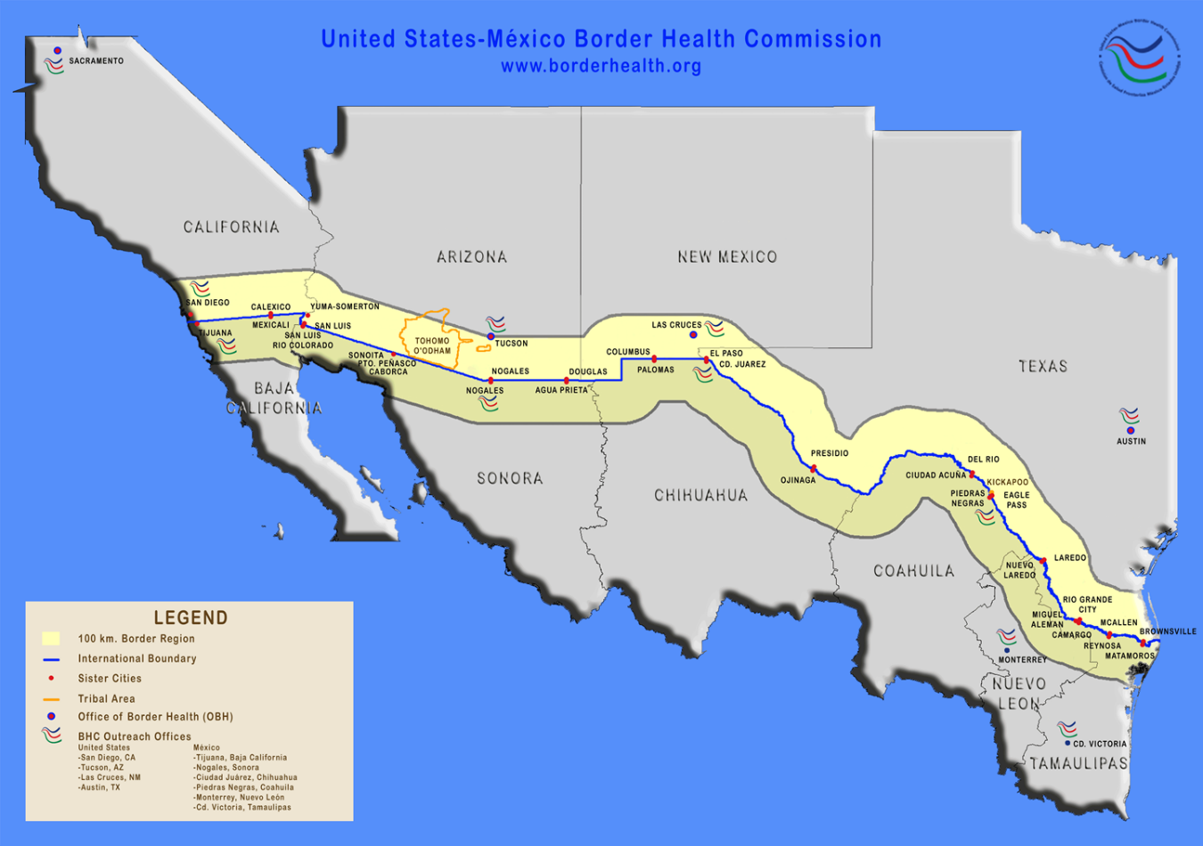

Figure 1: Map of the United States/México border region. Source: United States/México Border Health Commission, <http://www.borderhealth.org/border_region.php>