**The Application of Constructivist Grounded Theory Strategies to the Study of the Adolescent Experience of Motivational Interviewing-via-Co-Active Life Coaching**

Elizabeth Hall Ph.D.

(Corresponding Author)

Western University

1151 Richmond St.

London, ON

[ehall25@uwo.ca](mailto:ehall25@uwo.ca)

L Donald Morrow Ph.D.

Professor Emeritus

Faculty of Health Sciences

Western University

[donmor@uwo.ca](mailto:donmor@uwo.ca)

Academic Paper

Total word count: 7954

December 30, 2016

**Authors**

Elizabeth Hall received her doctorate of Health Sciences from Western University, Canada. Her research interests include motivational interviewing and coaching as interventions for positive behavior change in adolescents, as well as teacher uses of motivational techniques in the classroom and in counseling settings.

*Correspondence to: Elizabeth Hall, Western University. E-mail: ehall25@uwo.ca*.

Don Morrow is a Professor Emeritus of Health Sciences at Western University Canada. His research interests are in the area of using Motivational Interviewing and Coaching as interventions for health behaviour changes, especially those related to obesity/overweightness, physical activity, smoking cessation, and nutrition.

**Abstract**

This paper uncovers constructivist grounded theory (CGT) as a suitable, useful, and significant paradigm for those who wish to research the implications of reactions, sensitivities, processes and experiences of adolescents to a coaching method for positive behaviour change. The paper offers an application of the methodological tools of CGT; also described are the procedural aspects that make a CGT study both correct and rigorous. Further, this paper responds to the researcher/participant relationship by submitting techniques that, if utilized, may serve to enhance the understanding of participant responses.

**The Application of Constructivist Grounded Theory Strategies to the Study of the Adolescent Experience of Motivational Interviewing-via-Co-Active Life Coaching**

The processes of data collection, data analysis, and report writing are not distinct steps in the process – they are interrelated and often go on simultaneously in a [grounded theory] research project.

John Creswell (2007, p. 150)

# **The Iterative Process of Constructivist Grounded Theory**

This paper expands the terminology of constructivist grounded theory (CGT) by applying the specific approaches to a study conducted by me of the adolescent experience of Motivational Interviewing-via-Co-Active Life Coaching (MI-via-CALC). This paper details the sources of data used in the study; that is, intensive interviews with adolescents, memos of my conceptualizations, and extant literature. This paper also specifies the CGT strategies used in the study to provide “systematic guidelines for probing beneath the surface and digging into the scene” (Charmaz, 2006, p. 19).

## **Key Words**

Coding; constant comparison method; theoretical sampling; memo writing

## **Tools of the Study**

The methodical approach of CGT was useful in sustaining control of the research process; it provided the tools to facilitate researcher involvement in the research inquiry, and to maintain focus, structure and organization throughout the investigation. Further, the strategies for conducting data collection and analysis allowed interaction with the words of the participants and dispel the positivist conception of the researcher as “passive observer who merely absorbs their surrounding scenes” (Charmaz, 2006, p. 19). As such, I was called upon to be open and fair in my deliberation of the standpoint of the participants, and to foster reciprocity with the participants in order to learn from their experiences and perspectives. In addition, the CGT methodology, although systematic, was flexible, “open-ended yet directed, shaped yet emergent, and paced yet unrestricted” (Charmaz, 2006, p. 34). Therefore, I was guided but unfettered by the method of CGT when developing abstract understandings and theoretical conceptualizations of the material.

## **Questions Guiding the Study**

The principal epistemological questions of this study were:

* What is going on with the adolescent participant when engaging in MI-via-CALC?
* What are the adolescent participants saying about the experience of MI-via-CALC?

The answers to these questions were approached from an interpretive stance. During interviews, I attempted to remain open to all possible theoretical understandings, and created further questions from initial interview data.

## **Relationship of Participants and Researcher**

The quality of the qualitative interview comes from the relationship between the participant and researcher and the “reciprocity of the knowledge-power game” (Nunkoosing, 2005, p. 699). In order to equalize the research relationship, I reminded the participants that I was seeking their stories to develop my understanding of their experiences. Although I was asking the questions and directing our verbal exchange, I reiterated to participants that the in-depth interviews were not an interrogation. I also emphasized the notion that our conversations formed a connection between the “external world of events and our inner world of thoughts and emotions that constitute our subjectivities” (Nunkoosing, 2005, p. 704). In other words, it is through the honesty of our words that we can see our thoughts. By member checking, I gave further opportunity to clarify thoughts and construct meaning from the stories and language that the participants communicated (Fairclough, 1992, p. 42).

## **Source of Data**

The data that were collected for the study included the verbatim transcripts from interviews with adolescents who engaged in MI-via-CALC, and relevant literature, which has been interwoven throughout the evolution of the grounded theory of the study. The literature was used to “stimulate our thinking about properties or dimensions that we can then use to examine the data in front of us” (Strauss & Corbin, 1998, p. 45). The literature formed another voice in the contribution of theory building (Mills, Bonner, & Francis, 2006); therefore, this research is positioned within past and current knowledge of adolescent processes.

## **Intensive Interviews**

I used intensive interviews to gain understanding of the adolescent experience of MI-via-CALC, and to advance a theory that was created through the mutuality of the research experience by the participant and me, the researcher (Hiller & DiLuzio, 2004, p.3). The paradigmatic consideration of the interviews involved the participants and me as equal and active participants in the construction of ideas and knowledge, or the co-construction of meaning.

My task was to explore the detailed responses of adolescents to the questions asked during our interviews in order to achieve a greater understanding of their experience of MI-via-CALC. Two to three in-depth, open-ended interviews were conducted by telephone for approximately 45 minutes with each of the study participants. These interviews took place at the halfway mark of the eight-week MI-via-CALC coaching protocol, at the conclusion of the coaching sessions, and approximately one month after the coaching protocol.

Following the initial face-to-face meeting with each participant, the study interviews were conducted by telephone. The decision to interview by telephone was made in consideration of convenience for the participants; also, this mode of communication was consistent with the MI-via-CALC sessions. This approach to interviewing allowed convenient access to the participants (Cresswell, 2007) and perhaps diminished hesitancy to provide full and descriptive information that may have resulted from the participants being face-to-face with me (Krueger, 1994). The participants were comfortable and appreciative of meeting by telephone, and each stated that conversing seemed more natural, allowing for open and unfiltered responses. They reported feeling less stress about their commitment to the interview process because they were not required to dress up, show up, and risk being judged for appearance. One participant verbalized her opinion about the convenience of our telephone interviews:

I really like it because it's different like when I'm talking to adults I normally feel kind a’ nervous and self-conscious because I don’t know how they're viewing me and what they're thinking about and I like that we can't see each other because I'm not distracted by wondering if like you're writing things down or if you shift are you uncomfortable with what I'm saying and stuff so I like that it's so nice that I don’t have to take the bus or like ask my mom to drive me and I can just sit on my bed and talk … it's comfortable and way better that way.

Each interview was recorded in its entirety, and then transcribed verbatim. It is important to note that the transcribed responses by the adolescent participants included all interjections, vernacular, and repetition of phrases because this expression of speech can be a reflection of mood or a struggle in verbalizing concerns (Sandelowski, 1994). During the transcription process, I was able to explore the responses of the adolescent participants, and gain a deeper understanding of their perspective. While interviewing participants, and while transcribing the interviews, I continually made margin notes, wrote reflections, composed memos, and began to form initial codes (Huberman & Miles, 1994). These CGT tasks associated with data collection, management, and analysis were ongoing and simultaneous. The findings that surfaced from the first interview, for example, influenced the focus of successive interviews.

The second and third interviews were used as opportunity to collect additional data, and to affirm, clarify, and add detail to the data collected in the first interview. These interviews addressed information provided by the adolescent participants during the first round of interviews, and offered the footing for member checking, theoretical sampling, and verifying data for the emerging theory building. I conducted interviews and sought categories and themes from the data until saturation was reached.

## **Data Management**

Initially, I carefully read and re-read the transcripts of participant responses to the semi-structured interviews conducted by me. I took notes and formed an overview of the responses from each of the participants in order to comprehend the information from the interviews (Morse, 2003). I began to code the data and simultaneously write memos. Preliminary coding and memo writing about codes, comparisons of data, and my emerging ideas were completed in the transcript margins and additional paper. However, as synthesizing and theorizing (Morse, 2003) continued to develop and become more complex, post-it notes and highlighters, large sheets of paper for mapping, binders containing printed data and memos, and files of ideas were extended. Colours were assigned to corresponding codes, paper flags, post-it notes and highlighters to amalgamate data (see Table 1).

### *Example of Data Management*

Included in Figure 1 below is a photograph of my first working binder with examples of colour-coded post-it notes that were coordinated with flags and highlighters. Table 1 lists the colours that represent the emergent categories:

**Table 1: Colour Assignment to Initial Categories**

|  |  |
| --- | --- |
| Colour | Category |
| Pink | Helping others |
| Green | Acceptance of Self |
| Yellow | Speaking the truth |
| Blue | Problem Solving |
| Orange | Creative Exploration |

Figure 1: Picture of Binder with Colour Assignment to Initial Categories

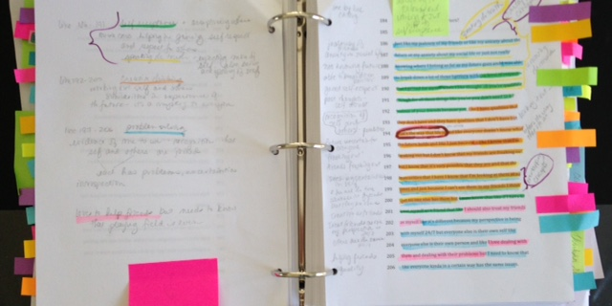

By using coordinating highlighters, flags and post-it notes, I was able to compare constantly the data by flipping from the data of one participant to another. Further, I used the post-it notes to jot down ideas and thoughts about what was happening with the data. My memos were recorded on the pages opposite to the verbatim transcripts. I also highlighted the significant segments of in-vivo, gerund, and line-by-line codes in order to go back to the words of the respondents, and find commonality in processes, issues, codes and categories.

The iterative spiral of analysis was realized in the practice of coding and analyzing the data; the process was circular rather than linear (Cresswell, 2007). As concepts developed, I reduced the number of colours to four, and assigned one colour for each concept and its related categories and subcategories. I did this to facilitate the organization of data management and analysis.

## **Data Analysis**

This section details the research method of CGT that was used in the analysis of the research data. Throughout the analytic process, I followed the guidelines of Charmaz (2006, 2014). Further, I applied the immersion/crystallization organization process (Miller & Crabtree, 1992, 1994) to the qualitative research cycle. This process “is much more iterative or recursive than linear, more like a multileveled roller coaster than a staircase” (Borkan, 1999, p.183). The core process of immersion/crystallization is outlined as follows:

* Initial engagement with the topic, and insight into the data while it is being collected
* In-depth description of issues, concepts, and contextual realities as they are being explored
* Crystallization of ideas and concepts during data collection and beyond
* Immersion and illumination of emergent insights from collected data and texts
* Explication and imaginative synthesis
* Corroboration and consideration of alternative interpretations

(Borkan, 1999, p. 183)

Immersion refers to the processes whereby I read and examined every portion of data that has been collected in order to be fully immersed in what the participants expressed. Crystallization is the process that I engaged in to identify connections between data segments and codes, and cogitate the immersion process in order to conceptualize analysis and theory from ideas that crystallized during immersion. I continued interplay with immersion and crystallization until a well articulated and substantiated theory was developed.

## **Coding**

Qualitative coding, the process of defining what the data are about (Charmaz, 2014), was the first analytic step of this study. The data encompassed a narrative reconstruction by the participants of their experience of MI-via-CALC, and not the actual experience itself (Charmaz, 2000).

Coding the transcripts by hand as opposed to computer generated code invention offered the advantage of microanalysis whereby I was able to apprehend the detail of the data and simultaneously assign codes to the data. The process allowed for consistency in code assignment. Although computer programs provide a means for storing data and organizing codes conceptualized by the researcher, I did not feel that this advantage outweighed the disadvantages of using a computer program. For example, researching an appropriate program, and training for its proper use seemed daunting. Also, the use of a computer program could “put a machine between the researcher and the actual data” (Cresswell, 2007, p. 165), creating a potentially undesirable detachment from the data.

### *Open Coding*

Consistent with the naturalistic inquiry paradigm of CGT, data collection and the analytic process were simultaneously and manually implemented. The analytic process was based on my immersion in the data, and repeated sorting and coding data. Analysis of the data began with open or initial coding, which involved identification of codes assigned to words and lines of the full interview transcript (line-by-line coding follows). “Words that reflect actions” (Charmaz, 2006, p.48) were used to advance ideas and considerations about the data (see Table 2). I examined and re-examined the full transcripts of each respondent so as not to miss any ideas, and to look for congruency in the data (Charmaz, 2014). The process of this initial coding allowed me to continue to immerse myself in the participant transcripts and also move into an analytic arena. This initial phase of CGT coding involved attaching phrases to lines and segments of the data transcripts (line-by-line coding).

Further, specific words and phrases used by participants (*in vivo*) were used as codes. *In vivo* codes are characteristic of social worlds (in this case, the social world of the adolescent) and reflect an abbreviated meaning for statements, experiences, and events that frame processes. Examples of *in vivo* codes are located in Table 2 below. Also, process-revealing action words (Charmaz, 2006) ending in *ing* (gerunds) became codes. This type of coding allowed for the conveyance of adolescent meaning and perspective. The purpose of this step in the analytic process was to reveal information that was significant to the research question. The example of initial CGT line-by-line coding displayed in Table 2 exemplifies the use of gerunds when coding for actions; this practice allows the researcher to go “deeper into the studied phenomenon and attempt to explicate it (Charmaz, 2014, p. 121).

**Table 2: Example** **of CGT Initial Coding for Actions**

|  |  |
| --- | --- |
| Line-by-Line Coding using Gerunds and *In Vivo* Codes | |
| Initial Code | Interview Statement |
| Trying “being more true to myself”  Creating the theme: “just saying no”  Stressing about saying no to friends  Recognizing fear of failure  Setting up friends for not meeting expectations  Identifying coach lead discussion  Giving friends “benefit of the doubt” Representing my truth | We talked about me just being more true to myself – that was like the theme of the first coaching session of being ok with just saying no because um I didn’t want to do it but rather than um saying no because I couldn’t do it but I felt stress because my friends might expect me to do it and then stop she showed me that I should stop setting up my friends for failure. That’s kinda like what we talked a lot about and she made me see - so giving them the benefit of the doubt that they would support me and then me being also not announcing that I don’t want to do this. |

Table 3 below shows general qualitative coding for topics and themes on which the researcher can focus. When compared to the chart above, which shows the CGT method of line-by-line coding that “goes deeper into the studied phenomenon” (Charmaz, 2014, p. 124), we see attention to subject matter rather than a developing association to process.

**Table 3: Example** **of General Qualitative Initial Coding for Themes and Topics**

|  |  |
| --- | --- |
| Line-by-Line Coding using Topics and Themes | |
| Initial Code | Interview Statement |
| Coaching conversation  First session  Friend conflict    Friend expectations  Lack of faith in friends | We talked about me just being more true to myself – that was like the theme of the first coaching session of being ok with saying no because um I didn’t want to do it but rather than um saying no because I couldn’t do it but I felt stress because my friends might expect me to do it and then stop she showed me that I should stop setting up my friends for failure. That’s kinda like what we talked a lot about and she made me see - so giving them the benefit of the doubt that they would support me and then me being also not announcing that I don’t want to do this. |

Charmaz (2014) suggests that throughout the line-by-line coding stage, the researcher should build on ideas and information. During the initial stage of coding, I was guided by the following questions that helped me to “see actions and to identify significant processes” (Charmaz, 2014, p. 127).

* What process is at issue here? How can I define it?
* How does this process develop?
* How does the participant act while involved in this process?
* What does the participant profess to think and feel while involved in this process?
* When, why, and how does the process change?
* What are the consequences of the process?

(Charmaz, 2014, p. 127).

During this stage of initial coding, codes were written in the left margin of each interview transcript; then the codes were compared. Similarities of concepts were noted and labeled on post-it notes and paper; colour-coded flags marked the colour-coded data (see Figure 4 above). This step of open coding generated an assembly of codes that were later reduced, reorganized, and reordered during the progression to focused coding (to follow in Section 1.7.2). The process of open coding generated many potential categories that were then verified and corrected (Simmons, 2011).

The following table offers a sample list of codes that were assembled during this initial stage of coding.

**Table 4: Sample of Initial Codes**

|  |  |  |
| --- | --- | --- |
| Initial Stage of Coding: Open Coding Sample List | | |
| In-Vivo Codes | Open Codes | |
| Liking the skin I'm in  Not set in stone  Weight off my shoulders  Gotta be me  Tooting my own horn  Knowing the target to hit  Put me on the right track  Putting coal in my engine  Helping me stay on track  Figuring it out  Can do attitude  Got to believe in yourself  Going through the motions  Parroting my words  Just doing it  Turning the light bulb on  Not sold on it  Taking a different tack  Not blurring the lines  Being who I am | Wanting success  Being guided  Being supported  Helping with organization  Feeling confident  Learning about self  Feeling competent  Taking initiative  Trying organization  Identifying problems  Saving face  Identifying clear goals  Realizing likeable personal traits  Increasing confidence  Believing in self  Working harder  Making self discovery  Being happy  Being a good role model  Seeing goals | Spending valuable time  Acknowledging wasted time  Feeling confident  Willing to try  Seeing success  Looking forward  Understanding self-values  Coming to conclusions myself  Walking through it together  Searching for the answers  Never going to be ready  Being open  Making correct choices  Feeling awesome  Talking to understanding other  Being less stressed  Talking openly  Being supported  Seeking affirmation  Being reassured |

During open coding, I quickly coded for everything possible; the resulting codes generated many potential categories (Glaser, 1978). As the coding process advanced, the codes were measured for fit and relevance to the CGT analysis (Charmaz, 2006). By being completely immersed in the data, I was able to verify, modify, and exhaust resulting categories and eliminate any codes that were not fitting or relevant to the developing categories that “crystallize the participants’ experience” (Charmaz, 2006, p. 54). Throughout this process, I remained open to possible theoretical connotations of the data and codes. This initial phase was followed by the focused coding phase.

### *Focused Coding*

In the second stage, I moved to focused coding, which involved further categorizing the data and identifying meanings, values, beliefs, and feelings (Charmaz, 2006) conveyed by the adolescent participants of this study. During this stage of coding, I took the codes that consistently appeared in the initial stage, and selected those that were significant and applicable to my research question. This phase of coding focused on the initial codes that lent theoretical direction to my study. When conceptualizing focused codes, I brought myself further into analysis by asking this question: “What kinds of theoretical categories do these codes indicate?” (Charmaz, 2014, p. 144). Further, I chose codes that amalgamated and integrated large portions of data. When concentrating on what my initial codes revealed, and while comparing codes, I proceeded to develop focused codes. Effectively, by developing focused codes, I was able to reduce the surplus codes from the bulk that I conceptualized during open coding.

Constant comparative analysis (see Section 1.9 to follow) and theoretical renderings produced variations to the initial coding. For example, the initial codes “trying ‘being more true to myself’”, “Creating the theme: ‘just saying no’”, “stressing about saying no to friends”, “recognizing fear of failure”, and “setting up friends for not meeting expectations” were amalgamated and abstracted to the focused code “conforming as a social ranking”. This was conceptualized through the recognition that, to make sense of her ‘self’, the participant was required to make sense of where she positioned herself in her social ranking. By revealing that she was ready to be true to herself, she countered her fear of her friends’ reactions to her saying no to their expectations. The participant came to the realization that, by conforming to what she thought her friends expected of her, she was placing herself in a social ranking with which she was unhappy. The rank in which she placed herself was that of conformer. Through MI-via-CALC she was able to recognize her dissatisfaction with the self-induced status of conformer; therefore, she was moving toward change. The result of the focused code “conforming as a social ranking” lead to the development of codes “lessening personal rights”, “injustice to self”, and “validating personal rights”.

Table 5 below demonstrates my movement from initial coding to focused coding, whereby my engagement with codes lead to the more abstract codes discussed in the previous paragraph. This movement was not separate or sequential; that is, the process was exploratory and integrative.

**Table 5: The Movement From Initial to Focused Codes**

|  |  |  |  |
| --- | --- | --- | --- |
| Movement From Initial to Focused Codes | | | |
| Initial Code | Interview Statement | Focused Code | Interview Statement |
| Trying “being more true to myself”  Creating the theme: “just saying no”  Stressing about saying no to friends  Recognizing fear of failure  Setting up friends for not meeting expectations  Identifying coach lead discussion  Giving friends “benefit of the doubt”  Representing my truth  Asserting self  Acknowledging “hiding behind something”  Trying coaching strategy  Experiencing success  Realizing friend reaction  Concluding that it was “in my head” | We talked about me just being more true to myself – that was like the theme of the first coaching session of being ok with just saying no because um I didn’t want to do it but rather than um saying no because I couldn’t do it but I felt stress because my friends might expect me to do it and then stop she showed me that I should stop setting up my friends for failure. That’s kinda like what we talked a lot about and she made me see - so giving them the benefit of the doubt that they would support me and then me being also not announcing that I don’t want to do this because I don’t want to get fat but just saying oh I um I don’t want to eat that and then just kinda leaving it at that instead of just hiding behind um something else and then um between that session and the next I used that and then I noticed that it worked – people didn’t really say anything and a big deal wasn’t really made of it so she (coach) kinda showed me that it was in my head that I was creating this weird situation. | Lessening personal rights  Conforming as a social ranking  Injustice to self  Validating personal rights | We talked about me just being more true to myself – that was like the theme of the first coaching session of being ok with just saying no because um I didn’t want to do it but rather than um saying no because I couldn’t do it but I felt stress because my friends might expect me to do it and then stop she showed me that I should stop setting up my friends for failure. That’s kinda like what we talked a lot about and she made me see - so giving them the benefit of the doubt that they would support me and then me being also not announcing that I don’t want to do this because I don’t want to get fat but just saying oh I um I don’t want to eat that and then just kinda leaving it at that instead of just hiding behind um something else and then um between that session and the next I used that and then I noticed that it worked – people didn’t really say anything and a big deal wasn’t really made of it so she (coach) kinda showed me that it was in my head that I was creating this weird situation. |

During the active process of focused coding, I revisited the data, examined, tested and conceptualized codes and then developed categories from the codes. This process was non-linear and iterative, and required attention to note taking, memo writing, and the constant comparison method (explanation follows). This circular interaction with data and codes led to the emergence of main and subcategories. In the above example, the category “conforming as a social ranking” crystallized from the data.

### *Axial Coding*

### During axial coding (Strauss & Corbin, 1990, 1998), I explored the relationships of categories, making connections between them. Strauss and Corbin (1990) recommend an organizational scheme for axial coding, and advise that this scheme will provide a frame for the structure of theory building. Cresswell (2012) recommends choosing an open category to be positioned as the core phenomenon to be investigated, and then relating other categories to it. The other categories are selected as follows:

1. Phenomenon: categories of conditions that influence the core category
2. Context: the specific conditions that influence the strategies
3. Core category: the idea or phenomenon central to the process
4. Intervening conditions: the general contextual conditions that influence strategies
5. Strategies: the specific actions or interactions that result from the core phenomenon
6. Consequences: the outcomes of employing the strategies

(Creswell, 2012, p. 426)

I selected one open coding category, “creating connection”, which became the core phenomenon in the axial coding example. The context codes “connecting with significant others” and “needing connections” denoted the adolescent participants’ expressions of attachment to the coaches:

I thought she (coach) was so kind and comprehensive and I don’t know I really liked her personality like she wasn’t really outspoken or anything or judgmental or anything like that … like I think that there are some people in my life who … it isn’t a positive experience but with my coach it was more like she was with me and for me. You know what I mean … does that make sense?

From there, I associated “need for collaborative support” as the causal condition or phenomenon; one participant articulated her need for collaboration as follows:

I was able to like feel that she understood me but the coolest part was that I learned to understand myself. The way that she set up our conversations was interesting because I came to all conclusions and she just kind a’ like helped me and that was good because she would prompt me to dig deeper whereas I wouldn’t ever be able to do that to myself.

Another participant expressed the need for collaborative support this way:

She is helping me because I didn’t really have an idea … I knew what I liked and stuff but I didn’t know what I wanted so … um … she’s guiding me along in a good way. She’s not forcing me to do anything. She’s really helping me on my own self and it's really good ‘cause I needed that.

Both examples reveal the participants’ need for collaboration with a trusted and supportive other, the CPCCs, and verify the connection that was created as a result of the coaching partnerships.

The intervening conditions “creating a façade to protect self” and “establishing independence” were realized after I reread the initial codes and categories. One participant expressed the action of self-protection; for instance, he consistently resisted the coaching relationship. Although he consented to taking part in the study, he took a well-worn path of opposition to others when engaging in MI-via-CALC. The following response verifies his predilection:

I'm getting nothing out … I'm getting practically nothing out of it. It's something that I would be doing on my own, so basically it's no benefit over what I would have done on my own … for me no positive benefits, no real negative benefits except for time but um and so for me it doesn’t really have positive or negative uh except just being a waste of time.

Charmaz (2014) advises paying attention to the language of the participants to help to frame the action; in the above example, the participant’s resistance of the coaching process was expressed as criticism of the coaching techniques. However, when disseminating his words, I perceived that the latter participant was pushing back in protection of his independence and in defense of his façade of insouciance. When I subsequently member checked, he partially agreed with my observation.

Figure 2, adapted from Creswell’s coding paradigm (Creswell, 2012, p. 428) exemplifies the nature and process of my rendering of axial coding:

Figure 2: Illustrated Example of Axial Coding

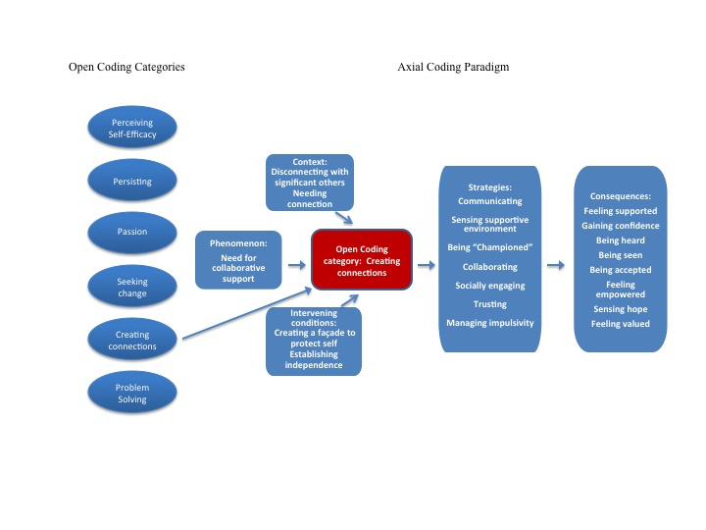

*Figure 2.* Axial coding paradigm adapted from *Qualitative Inquiry and Research Design: Choosing Among Five Approaches (3rd ed.)* (p. 428), by J.W. Cresswell, 2012, Thousand Oaks, CA: Sage.

The strategies and outcomes of creating connections, which appears in the list of open coding categories on the left, are listed in the above diagram. The context of creating connections was the adolescent need for connection and disconnecting with significant others. The phenomenon was the adolescent need for collaborative support, and the intervening conditions were creating a façade in self-protection and in the establishment of independence. The movement from left to right shows this process, and the list of strategies and consequences of creating connections. Through this exercise of axial coding, creating connections emerged as a main concept of the data. This process of axial coding was repeated several times until my concentrated emersion in the data lead to the crystallization of concepts, categories, subcategories, and the core category.

## **Constant Comparison**

Similarities and differences in the properties of the codes were sifted and sorted during constant comparison, which is a method to move concrete data into abstract thought that ultimately advances the grounded theory. Through constant comparison, I moved back and forth from the adolescent participant transcripts, codes, categories, my memos and notes, and extant literature to conceptualize how the substantive codes and categories relate to one another. This constant comparison method was used to fit the data pieces together in order to recognize uniformity and variances in the emerging concepts. Information gathered during the interviews produced theoretical renderings when constant comparison of data revealed repetition of specific codes and concepts. Throughout the study, I used constant comparison as a way of interacting with the data, comparing new information with previously identified codes and categories. I approached the data with an openness regarding what was happening in the interpretation of the data and what process or action was being represented through the data. Concurrently, I wrote memos to record my interpretations and to crystallize my analysis (see Section 1.12: Memo Writing).

The following example, Table 6 and Figure 3, illustrate the application of constant comparison in this study. The *in vivo* code “stressed out” was consistent with each of the participants of the study. After recognizing the repetition of this common phrase, I began to ponder the questions, “What does ‘stressed out’ mean to each participant?” Through the practice of constant comparison, I looked at the possible connections between initial codes. During this process, I gained direction in the creation of the focused code “creating connections” and in the formation of my analysis.

**Table 6: Application of Constant Comparison Method**

|  |  |
| --- | --- |
| Constant Comparison Method Applied to In Vivo Code “Stressed Out” | |
| Participant | What does “stressed out” mean? |
| Woodsman | Not meeting my parents’ expectations about my test results and blowing off studying and stuff. |
| Ari | I want to get an honour roll grade because I know I can. |
| Barrister | My mom expects me to figure it out but I don’t think that I want to go away and basically I think she expects me to but I don’t feel ready for it. |
| Pink | Things that I should be saying or shouldn’t be saying and that type of thing that maybe other people have expectations about. |
| Geo | I had some tough situations with organization that my teacher was disappointed about and that’s um it's a problem. |
| Veetee | That people will see that things aren’t perfect and that they’ll see past my façade. |
| Beyoncé | People seem to have their lives together and when I'm talking to them I'm stressed out because I pretend that I do too because I don’t want them to think that I'm a loser. |

The participants were asked to provide feedback on my interpretation (member checking); each agreed with my analysis that being “stressed out” was related to the need to create connections with others. That is, the data collected from adolescent participants revealed that the feeling of being stressed out was in all cases a reaction to the perceived opinion and expectations of others to the adolescent. This notion aligns with Siegel (2013) and Lerner, Fisher, and Weinberg (2000) who advance that adolescents need the collaboration, friendship and respect of important others to affirm feelings of safety and security that contributes to growth in confidence. My use of the constant comparison method facilitated in the conceptualization of “creating connections” as a focused code.

Figure 3: Data Interaction and Conceptualization through Constant Comparison

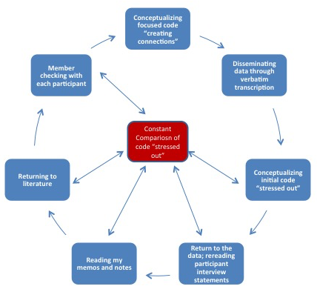

The bi-directional arrows in Figure 6 indicate that the method of constant comparison is ongoing and interactive. Throughout the process of grounded theory construction, I constantly and iteratively compared elements of data, codes, categories, and concepts, and assembled the fragments to form unified ideas and advance theory.

## **Theoretical Sampling**

I used theoretical sampling to increase the data collection for the purpose of examining relationships and variations that were emerging in the original data (Corbin & Strauss, 2008). The further collection of data gleaned new information that was needed to ground the concepts and to understand the patterns that began to appear (Strauss & Corbin, 1990). Charmaz (2006) endorses subsequent interviews and observations to allow for theoretical sampling in order to build conceptual ideas.

During theoretical sampling, I:

* Determined the focus of the interview
* Varied the sample by adding three participants
* Used the new data to ask analytical questions
* Approached the previous data for further deliberation

My aim in theoretical sampling was to uncover distinctive participant experiences of MI-via-CALC that could enhance theory building; this provided an opportunity to ask specific questions and investigate properties in order to advance and saturate concepts and categories that emerged from the preceding data collection, coding, and categorizing (Charmaz, 2006, 2014). Additionally, theoretical sampling facilitated the development of properties within the categories until no new properties emerged (saturation). Further, it was a means of member checking; that is, the participants were asked to confirm emerging findings.

For example, early in the data analysis, I identified a category that related to intrinsic disposition and extrinsic motivation. In analysis of the first interviews, I noted that a participant described his interactions with his CPCCs as presenting choice “so I didn’t feel that I was forced to, so I really could do, if I wanted to I would. If I didn’t want to, I didn’t have to. I liked that … it was motivating”. More instances of that concept arose, and I defined the category “positioning of power” to denote the symbiotic relationship of motivation and intrinsic/extrinsic impetus. I wondered how the adolescent perceived the process of MI-via-CALC in establishing a personal “positioning of power” to change.

My theoretical memos helped me to explore and refine the notion of “positioning of power”. Theoretical sampling involved scrutinizing my ideas and the data collected from participant responses, and moving back and forth between the category, the data, and my conceptualizations (Charmaz 2006). In subsequent interviews with the first group of participants and the initial interviews with the three new participants, I asked the following question about this aspect of the coaching experience:

1. Would you say that you are in the power position when it comes to motivation to change?
2. Do you place others (family, friends, teachers, coach) in the power position for motivational influence to change?
3. Comment on the positioning of power for change that occurred between you and your coach.
4. How important is it to have balanced position of power – you and a supportive other?

I reflected on a participant’s responses to my intensive inquiry about intrinsic disposition and extrinsic motivation to change. She had a high intrinsic disposition to “become a good diabetic”, which meant exercising regularly and being diligent about carbohydrate intake in order to maintain an optimal blood glucose level. She struggled with diabetes maintenance since she was six years old, and relied on extrinsic factors (her mother’s daily menu, her friends’ invitations to order pizza) to control her eating. She felt that it was time for her to become “a good diabetic” and looked forward to the MI-via-CALC sessions to help her gain control of her exercise and dietary habits. She admitted that being honest with her friends about dietary changes was difficult, because so much of her social life was “sitting around eating all the time”. The participant revealed that she felt acknowledged by her coach during their first session, which included a discussion of the issues that she was having with her friends and her dietary habits. However, her reaction to subsequent coaching sessions follows:

She would tell me what I was and I wanted to talk about other stuff but she always brought me back to her agenda … like I wanted to discuss exercising for health, not weight loss, but she didn’t stick to that. I was looking for motivation to be a good diabetic but I never got it.

Figure 4 below is a matrix that I drew to capture succinctly the essence of our interview, and to provide a visual from which to build my developing theory.

Figure 4: A Matrix of Personal “Positioning of Power” to Change

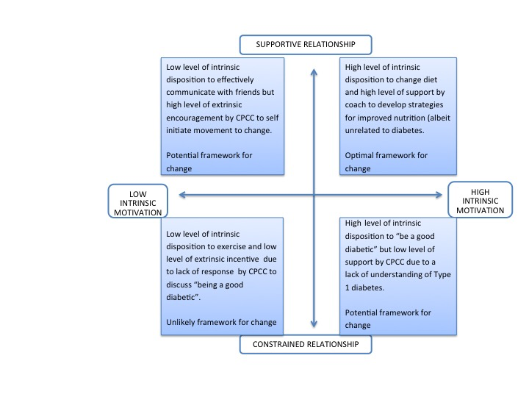

This matrix illustrates the likelihood to change in accordance with the responses of the participant to my question, “How likely are you to follow through with (change behavior)?” The matrix shows each quadrant in comparison to a supportive versus constrained relationship, and high intrinsic motivation versus low intrinsic motivation. For example, when pairing low intrinsic motivation with a supportive relationship, a potential framework for change may result. Dissimilarly, when coupling high intrinsic motivation with a supportive relationship, the framework for change is optimal. The following memo gives testimony to my thoughts as I moved through the process of exploring and analyzing the data.

**Figure 5: Memo on Personal “Positioning of Power” to Change**

Veetee (adolescent participant) was not intrinsically motivated to change her behavior with her friends, but the encouragement of her CPCC provided her with potential motivation to change. Similarly, she saw potential for change to become a “good diabetic” because she was intrinsically motivated, although she did not perceive coaching support. Veetee struggled with intrinsic motivation to regularly exercise (one of the reasons for wanting to try MI-via-CALC) but did not receive the coaching support that she was anticipating, and therefore described an unlikelihood to change. However, her desire to maintain proper dietary habits, and her coach’s interest in nutrition, provided an optimal framework for change. In that case, Veetee’s personal “positioning of power” for change placed the coach and the participant on equal footing; both played an equivalent role in creating the optimal framework for change.

## **Negative Cases**

Negative cases or counter-examples that are met during the research process are important to the process of constant comparison (Charmaz, 2014; Strauss & Corbin, 1990) because “they can unlock vital analytic insights that contribute to theory development” (Watling & Lingard , 2012, p. 853). By comparing the properties of negative and positive cases to the properties of the category, I was compelled to meditate codes and categories in order to determine the developing concepts.

## **Memo Writing and Clustering in Facility of Analysis**

As analysis of the data began, I wrote memos (Charmaz, 2006, 2014; Corbin & Strauss, 2008) to assist in recording new insights and document emerging categories, concepts, and analytic ideas. The resulting memos helped me to conceive categories and served to forward my interpretations. Charmaz (2014) advises that the process of memo writing should be free and informal, and recommends that memos should remain private. My memos were a form of conversing with myself; they were tangible thought bites, and proved to be a supportive stride in my excursion into analyzing and theorizing. Often, I audio recorded my crystallizing thoughts and questions, and later transcribed them; similarly, I typed my reflections as they transpired. Frequently, I hand wrote my ideas and hunches on anything that I could find; in fact, Kleenex, paper napkins, and the back of receipts served as field equipment. Figure 6 offers evidence of my impromptu memo-writing.

Figure 6: Examples of Extemporaneous Memo Writing

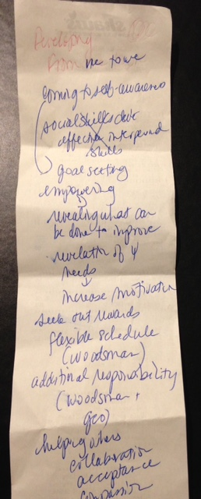

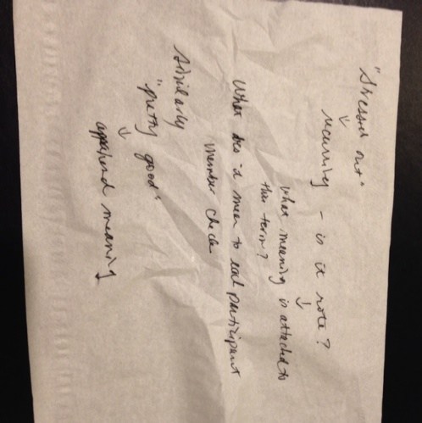

Additionally, I used the shorthand techniques of clustering and diagraming (Charmaz, 2006, 2014) to provide a starting point from which to organize my thoughts and material. Clustering allowed me to explore various paths in the journey of analysis and theory building. Charmaz (2014) recommends following the directions below when exploring codes and forming clusters:

* Start with the main topic or idea at the center
* Work quickly
* Move out from the nucleus into smaller sub clusters
* Keep all related material in the same sub cluster
* Make the connections clear between each idea, code, and/or category
* Keep branching out until you have exhausted your knowledge
* Try several different clusters on the same topic
* Use clustering to play with your material

(Charmaz, 2014, p. 185)

I offer the following examples in Figure 7 as evidence of my adherence to Charmaz’s recommendations. The *in vivo* code “getting it done” is at the center of both photographs and represents the central idea or core category of the grouping of categories and concepts. The first photograph was taken after I drew my initial conceptions in the sand; my writing implement was the feeler of a horseshoe crab (also pictured below). This photo, and the one to follow, confirms that I observed Charmaz’s (2014) recommendation to “liberate your creativity” (Charmaz, 2014, p. 184) through spontaneity and provide “a direct visual, as contrasted with a solely mental image” (Charmaz, 2014, p. 185) from which to delve into the writing process.

Figure 7 provides an illustration of the clustering exemplar.

Figure 7: Rendering of Initial Stages of Clustering

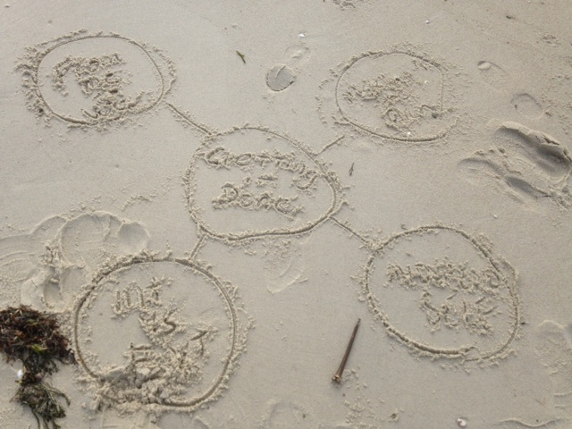

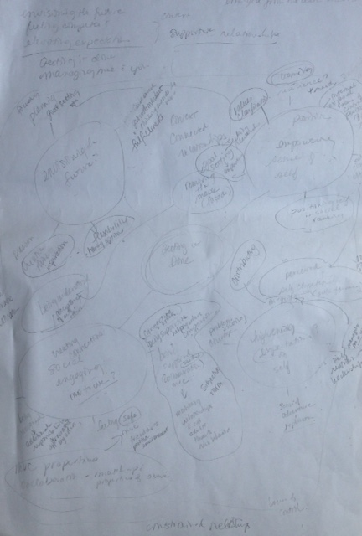

## **From Codes, Categories and Concepts to the Core Category**

Through the use of constant comparison of categories and my abstractions written in memos, I considered how the emerging categories and concepts reflected the adolescent experience of MI-via-CALC. In order to enhance and advance the crystallization of my abstractions during this discovery process, I continued to read extant theory and relevant literature. Cognizant of the need for abstraction in the conceptualization of theory, I looked beneath the surface to find inherent or potential meaning in the words of the adolescents; I looked for connotation of values, beliefs, and principles. I stepped back and reflected on the data collected from interviews with adolescents, on my ideas, reflections and interpretations, and on relevant literature. Further, I arranged and rearranged categories with concepts to formulate the optimal representation and organization of data.

Figure 8: Map of Concepts, Categories, and Subcategories of “Getting it Done”

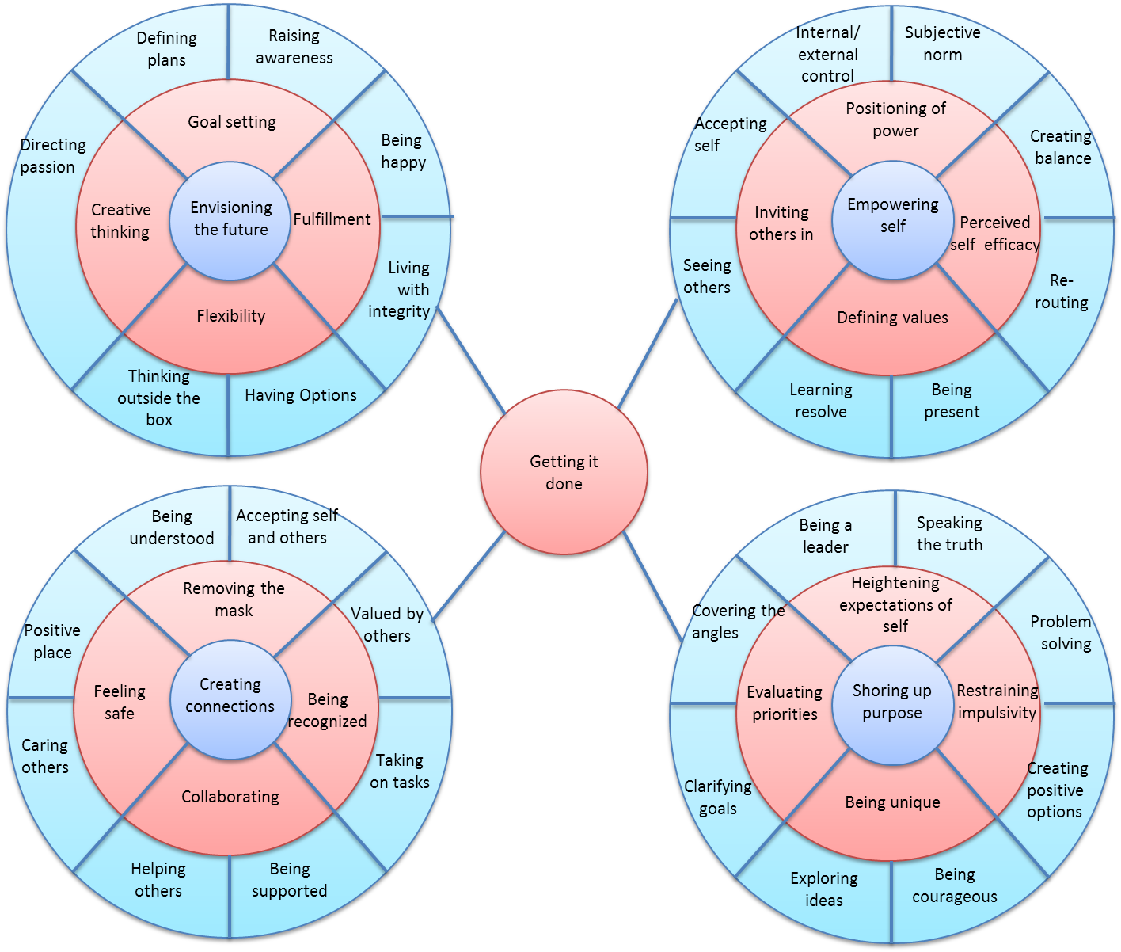

Figure 8 illustrates the categories, subcategories and concepts that scaffold the conceptualization of the substantive theory that was the end product of this CGT study. The four main concepts were linked by theoretical categories that formed patterns within the data. For example, the discovery of the theoretical categories “removing the mask,” “feeling safe,” “collaborating,” and “being recognized” were used to promote understanding of how the participants created connections with others. The core category “getting it done,” an *in vivo* code, is redolent to the language of the adolescent. As depicted in Figure 8, the assemblage of the concepts “envisioning the future,” “creating connections,” “empowering self,” and “shoring up purpose” were interlocked by the core category “getting it done.”

## **Summary**

This paper presented the practical application of the methodological tools of CGT. As advised by Charmaz (2006, 2014), I exercised openness and creativity of an unrestricted mind, and explained the steps that I took in the process of this study. I included examples of my data management, initial coding for action in comparison to general coding, samples of open codes, the movement from initial to focused codes, axial coding, constant comparison method, memo writing, and mapping of concepts, categories and subcategories. I also revealed the core category “getting it done.”

## **References**

Borkan, J. (1999). Immersion/Crystallization. In B.F. Crabtree & W.L. Miller (Eds.): *Doing qualitative research* *(2nd ed.)* (p. 179 – 194). Thousand Oaks, CA: Sage.

Charmaz, K. (2000). Grounded theory: Objectivist and constructivist methods. In N.K. Denzin and Y.S. Lincoln (Eds.), *Handbook of Qualitative Inquiry.* (pp. 509 – 535). Thousand Oaks, CA: Sage.

Charmaz, K. (2006). *Constructing grounded theory, a practical guide through qualitative analysis.* Thousand Oaks, CA: Sage.

Charmaz, K. (2014). *Constructing grounded theory (2nd ed.)*. Thousand Oaks, CA: Sage.

Creswell, J.W. (2007). *Qualitative Inquiry and Research Design*. Thousand Oaks, CA: Sage.

Creswell, J.W. (2012). *Qualitative Inquiry and Research Design: Choosing Among Five Approaches (3rd ed.)*. Thousand Oaks, CA: Sage.

Fairclough, N. (1992). *Discourse and social change*. Cambridge, UK: Polity.

Glaser, B. (1978). *Theoretical Sensitivity: Advanced in the Methodology of Grounded Theory*. Mill Valley CA: Sociology Press.

Hiller, H. & DiLuzio, L. (2004). The interviewee and the research interview: analyzing a neglected dimension in research. *The Canadian Review of Sociology and Anthropology, 41*(1), 1-26.

Krueger, R. (1994). *Focus groups: A practical guide for applied research. (2nded.)* Thousand Oaks, CA: Sage.

Lerner, R.M., Fisher C.B., & Weinberg, R.A. (2000). Toward a science for and of people: Promoting civil society through the application of developmental science. *Child Development, 71*, 11-20.

Miles, M.B. & Huberman, A.M. (1994). *Qualitative Data Analysis: An Expanded Sourcebook (2nd ed.).* Thousand Oaks, CA: Sage.

Miller, W.L., & Crabtree, BF. (1992). "Primary care research: A multimethod typology and qualitative roadmap." In BF Crabtree and WL Miller (Eds.) *Doing Qualitative Research* (1st ed.) (p. 3 – 28) Newbury Park, CA. Sage Publication.  pp. 3-28).

Miller, W.L. & Crabtree, BF. (1994). "Clinical Research." In NK Denzin and YS Lincoln (Eds.) *Handbook of Qualitative Research* (pp. 340-352). Thousand oaks, CA: Sage Publications.

Mills, J., Bonner, A., & Francis, K. (2006). The development of constructivist grounded theory. *International Journal of Qualitative Methods,* 5, (1), Article 3.

Morse, J.M. (2003). The Adjudication of Qualitative Proposals. *Qualitative Health Research, 13*, 739 – 742.

Nunkoosing, K. (2005). The problems with interviews. *Qualitative Health Research, 15*(5), 698 – 706.

Sandelowski, M. (1994). Notes on Transcription. *Focus on Qualitative Methods, 17*(4), 311 – 314.

Siegel, D. (2013). *Brainstorm*. New York: Penguin Random House.

Simmons, O.E. (2011). Why classic grounded theory. In V. Martin & A. Gynnild (Eds.): *Grounded theory: the philosophy, method, and work of Barney Glaser.* (p. 15 – 30). Boca Raton, FL: Brown Walker.

Strauss, A., & Corbin, C. (1990). *Basics of qualitative research: Grounded theory procedures and techniques*. Newbury Park, CA: SAGE Publications.

Strauss, A., & Corbin, J. (1998). *Basics of Qualitative Research: Grounded Theory, Procedures and Techniques.* Newbury Park, Ca: Sage Publications.

Watling, C.J., & Lingard, L. (2012). Grounded theory in medical education research: AMEE Guide No. 70, *Medical Teacher, 34*(10), 850-861