The Relationship between toilet availability and *Escherichia coli* presence in public-access water in the Dominican Republic

**Abstract**

Insufficient toilet facilities put 2.5 billion lives in developing countries at risk due to lack of improved sanitation resulting in diseases that proliferate when adequate hygiene is not available (GLAAS expand acronym2014). Without proper waste management those with limited toilet access are compelled to void feces and other waste in areas resulting in fecal contamination of water sources. In this pilot study, publicly accessible (PA) water in the Dominican Republic was tested for the fecal indicator, *Escherichia coli*. Since the existence of coliform bacteria indicates fecal contamination, data collected from areas with varying toilet facilities were analyzed to examine the relationship between toilet accessibility and *Escherichia coli* presence. Water samples were collected from 49 sites in Santo Domingo and Sosua, DR from neighborhoods of differing SES (based on education and income). Using the Coliscan Easygel method, samples were tested for total coliform and *Escherichia coli* colonies; counts were documented based on GPS location and SES. We found that *Escherichia coli* concentration was 10 times higher in extremely poor neighborhoods relative to affluent neighborhoods and there is a significant (0.01) relationship between poverty and limited toilet facility, indicating that limited toilet facility relates to *Escherichia coli* presence in PA water.

Index words: water quality, toilet access, *E. coli*, Dominican Republic, waterborne disease

**Introduction**

The island of Hispaniola houses two countries with overlapping histories but unique issues. The developing country of the Dominican Republic has experienced several civil wars and was historically claimed by various countries before first winning independence from Haiti in 1844, and then independence from the United States in 1924. Although the nation has endured a turbulent past, it has often been a refuge for citizens of its neighboring country and for immigrants across the world, thus increasing the population of the Dominican Republic at rapid rates (Kosiniski, 2009). Within the country, the transition from an agricultural economy to an industrial and service market in the past 20-30 years has also driven an inner-country migration of Dominican citizens relocating from rural communities to urban cities (Aide & Grau, 2004). Currently the Dominican Republic has a population of about 10 million people and about 60% are located in urban areas (World Bank, 2014).

Due to the rapid urban swell, advances to maintain a high quality of life in regards to unclear waste management and sanitation may not keep up with the growing need. Despite advances in water technology in the recent decade, water quality is still a threat globally in developing nations, like the Dominican Republic. The depletion of groundwater and the unregulated disposal of wastewater and solid waste are creating problems that might become difficult to remedy. In addition to rural communities, even the newly built urban areas and large tourist attractions frequently do not have adequate sanitation.

Fecal-coliform bacteria is a type of microbial bacteria that exists in the intestines of warm-blooded animals and if found in a body of water, indicates fecal contamination. Consumption of water contaminated with microbial bacteria can lead to water-borne diseases such as typhoid, diarrheal disease, *E. coli* poisoning and chronic diseases such as hemolytic uremic syndrome and sepsis (Baum, Kayser, Stauber, & Sobsey, 2014). The Dominican Republic (DR) is still facing issues regarding bacterial infections and unsafe drinking and recreational water due to the lack of satisfactory water treatment and waste management. Insufficient toilet facilities risk 2.5 billion lives in developing countries void of improved sanitation (GLAAS 2014). Without proper waste management those with limited toilet access are compelled to void feces in areas?? resulting in fecal contamination of watersheds. The World Health Organization (year)estimates that only 49% of collected waste water receives treatment in the DR, thus making the subsequent drinking water treatment process all the more difficult when plants use those contaminated source waters.

Although there is a sewer treatment plant in the area, a study conducted by Phillips and colleagues states that a large quantity of raw wastewater still enters the Yaque del Norte River, polluting the watershed. This is a theme reoccurring throughout the country with sources of water contamination including industries, municipal wastes, hog farms, poultry farms, slaughterhouses, non-point sources of runoff and the fecal dumping of inhabitants along watersheds. Water samples from INAPA, the Dominican Republic’s main water company serving 40% of the population, are routinely tested for coliform bacteria and these tests show that INAPA’s aqueduct contamination levels are steadily increasing (from 17% in 1994 to 23% in 1998 and so forth and this may be due to the polluted water sources INAPA receives its water from (Phillips, Russell, Turner, 2007).

*Standards*

Many of the issues in polluted water supply come from the regulatory actions of the waste management and water treatment officials. Compared to a developed country, i.e. the United States, the differences in water quality standards becomes clear.

The World Bank (year) describes improved sanitation as piped sewer systems, septic tanks, latrines, and composting toilets. According to the World Bank, 100% of the urban American population had access to improved sanitation facilities in 2013. In the Dominican Republic only 82% of the urban population had access. The World Bank also defines Improved Water Source as the presence of piped water, public taps, pipes, wells, springs, and rain water collection in a household, plot or yard. Ninety nine percent of the urban population in the US has improved water access while 83% of the Dominican Republic’s urban population has access to improved water according the World Bank.

Eighty three percent 83% may seem adequate however, the research conducted by Baum et al. (year) suggests that this number is not representative of the access to safe drinking water Dominicans actually have. Their study, *Assessing the Microbial Quality of Improved Drinking Water Sources: Results from the Dominican Republic*, argues that these numbers do not account for the microbial bacteria that is piped into homes, therefore in actuality 47% of this “improved drinking water” is unsafe to drink.

On the other hand, in the United States the Total Coliform Maximum Contaminant Level Goal, or the level of coliforms in drinking water which there is no known or expected risk to health, is zero. In other words, the number of coliforms allowable in drinking water in the U.S., is none. The regulatory process to ensure that safe drinking water is made available to U.S. citizens is implemented by the EPA, which instates a plant violation if 5% of the 40 plus routine water samples are coliform-positive in a month at any water treatment plant.

INAPA and USAID have goals to get 95% satisfactory drinking water in the Dominican Republic and Dominican standards also claim that the presence of coliforms in over 5% of samples indicate that water is no longer potable. However, consistent research on the quality of water in the Dominican Republic is lacking to quantify the countries progress towards that goal.

This study will aim to determine if bacteria-ridden drinking water is related to the availability of toilet availability by comparing the water samples of various water source sites in two cities in the Dominican Republic.

[Can you describe about how open defecation or voiding feces in certain areas can contaminate ground water or other drinking water supplies? ]

**Methods**

For this cross-sectional pilot study, water samples were collected from 49 public-assessable sites in the two cities of Santo Domingo and Sosua, Dominican Republic. Public-assessable areas were defined as communal areas where people receive water, such as public restrooms, restaurants, community spigots, rivers, etc. Water samples were only collected from a site if it could possibly be ingested during use, i.e. was to be used for cooking, food washing, or drinking. Samples were collected using the convenience sampling method. While compiling data, one sample was dropped from the total count, as there was not enough information to classify the sample,?? unclear dropping the total number of analyzed samples to 48.

At each site, a water sample was collected in an EPA compliant 100 mL sampling bottle, the temperature of the sample was logged, and the location of the site was documented using GPS coordinates. Each sample was then placed in an ice cooler until it could be refrigerated (cooler time did not exceed 6 hours).

To capture the whole picture of water quality in the two cities samples were collected from neighborhoods of differing socio-economic status, based on level of education and income. Where did you get these data? We placed these neighborhoods into quadrants: Upper Middle Class, Middle Class, Poverty, and Extreme Poverty based on multiple key informant?? How did you select key informants? data. These quadrants were utilized to maintain even distribution of SES in all neighborhoods and not a confounding factor. Unclear – please re-work

*Coliscan Easygel Method*

We utilized Coliscan Easygel Solution (provide a citation), which tests for coliform bacteria and specifically, *E coli*. 5 mL of sample water was mixed with one bottle of Coliscan Easygel medium using a sterile milliliter dropper and the combined liquid was placed in a Petri dish; within 45 minutes the solution solidifies. The enzyme in the medium in the changes colors when in contact with coliform bacteria and within 24-48 hours the coliform bacteria colonies will turn a pink color and *any E. coli* colonies present will turn purple. Colony counts were taken, logged, and recorded via photograph. The colony forming units or CFUs per 100 mL of water were then calculated.

To determine how limited toilet facility relates to fecal bacteria presence in PA water – (a clearer connection needs to be made between these two variables) observation of a toilet facility at the site that the water sample was collected was noted and variable for presence or absence of this improved sanitation was created. Unclear statement. The definition of ‘Improved sanitation’ according to the World Bank is the presence of a piped sewer system, septic tanks, latrines, and/or composting toilets. (citation)

Although some Dominicans utilize source water (rivers, ponds, lakes) for cooking, drinking, and washing we were only interested in testing the “improved water management sources” which are considered purified water. Discardingt source water samples, and keeping samples from piped water sources we ended up with 32 Public-Assessable and drinking water sites and examined prevalence and odds ratio.

[State hypotheses and/or research questions]

[Define variables, describe how they were operationalized and then provide a rationale for the statistical tests]

**Results**

Since the total coliform and *E. coli* samples were not normally distributed, *E. coli* and coliform bacteria was categorized into presence and absence of colonies. The Fisher Exact test showed that coliform bacteria presence is dependent on neighborhood poverty status (p-value= 0.0048). The Wilcoxon Rank Sum’s test showed that coliform colony counts are significantly higher in poor neighborhoods than in non-poor neighborhoods (p-value=0.0027). *Escherichia coli* concentration was 10 times higher in extremely poor neighborhoods relative to affluent neighborhoods and there is a significant correlation (0.01?? report r value, with df and p-value) between poverty and limited toilet facility, indicating that limited toilet facility relates to *Escherichia coli* presence in PA water

The odds of having contaminated water was 6 times higher for those who did not have access to toilets compared to those who did. (report OR, and p-value)There is an 82% prevalence of -coliform bacteria in water if there is no toilet availability. Thus supporting our hypothesis that limited toilets is related to poorer water quality.

**Discussion**

*Disparities*

Our research uncovered an issue of disparity, or inequality between poor and non-poor communities. We know there is a deafening?? need for improved sanitation and waste disposal but in 2000 the WHO estimated that 49% of collected wastewater in the Dominican Republic received some treatment; however, these results show that wealthy populations receive disproportionate amounts of improved water.

Dominicans of lower SES are more likely to have less access to toilets and waste disposal, thus creating a cycle of waste ?? Discuss this in some detail. Low SES residents have no where to discard their waste, so they place it out in their communities uncovered, after a rain event this waste gets washed into the nearest watershed and consequently pollutes the water that will later be piped into their communities for drinking. – this needs to be stated earlier in the paper. Without readily available potable water provided to the public, individuals are obligated to either purchase purified water or, if not financially stable, make use of polluted water on a daily basis. Those lacking the financial means to consistently purchase purified water are forced to consume microbe-ridden water in order to drink, cook meals, and carry out everyday tasks, consequently exposing themselves to microbial enteric pathogens that can result in fatal preventable disease.

*Limitations*

Since samples were collected from publically assessable water sources in many occasions a toilet was present but that doesn’t represent the toilet accessibility for the entire community. For example, in a low SES area a sample would be taken from a public lot, such as a school, clinic, restaurant, etc. that had a toilet facility present while a majority of homes surrounding the communal space, were devoid of toilet access. Since the location in which the sample was collected had observed improved sanitation we marked the sample as toilet present. In actuality the number of communities lacking toilet facilities could be more than what our study indicates.

Another limitation was the small sample size. This pilot study was conducted to establish if there is a need to conduct research on the quality of water and sanitation in Santo Domingo, Sosua, and the Dominican Republic as a whole. Although this small sample of data has ascertained valuable information on the current state of drinking water in two cities, more research must be conducted to determine if a larger sample including multiple cities will produce similar results.

*Future Recommendations*

Frequently, nearby farms and animal processing plants can contaminate water sources with fecal matter so future research should seek to find methods to determine what coliform bacteria is present due to human waste and which is from animals. Although both sources of microbial bacteria are harmful to the health of humans, if ingested, determining the cause will create a broader understanding of how toilet availability relates to water quality in the Dominican Republic and countries similar to the developing nation.

There is a lack of research in the Dominican Republic so more water quality discussion and research with larger sample sizes needs to be carried out to determine the health outcomes water contamination may cause to support water policy reform. Regulations on water treatment and waste management plants could decrease the amounts of fecal waste found in piped water but more data is needed.

**Tables**

Table 1

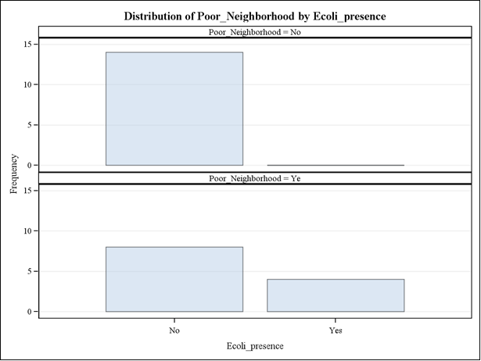

Table 2

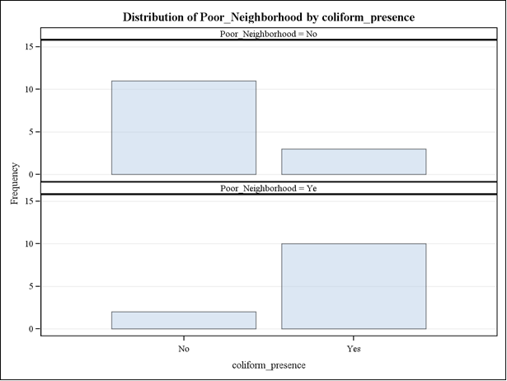

Table 3

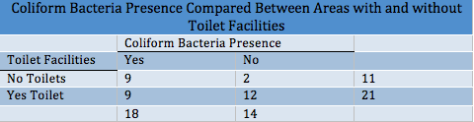

**References**

Aide, T.M., Grau, H.R. (2004). *Globalization, migration, and Latin American*

*Ecosystems. Science, 305*, 1915-1916. Retrieved from <http://www.sciencemag.org/content/305/5692/1915>

Ashbolt, N, J. *(2004). Microbial contamination of drinking water and disease outcomes*

*in developing regions. Toxicology, 198,* 229-238.

Baum, R., Kayser, G., Stauber, C., & Sobsey, M. (2014). *Assessing the microbial*

*quality of improved drinking water sources: results from the Dominican Republic. American Journal of Tropical Medicine and Hygiene, 90 (1)*, 121-123.

Kosinski, S. State of Uncertainty: Citizenship, Statelessness and Discrimination in the Dominican Republic. *Boston College International and Comparative Law Review. 32(2).* [Retrieved from](C:\\Users\\pbanerje\\AppData\\Local\\Temp\\Retrieved from http:\\eds.b.ebscohost.com.ezproxy.gsu.edu\\eds\\pdfviewer\\pdfviewer?sid=c7df4405-7aa3-46b8-84c9-6d4733146c58@sessionmgr112&vid=5&hid=103) *[http://eds.b.ebscohost.com.ezproxy.gsu.edu/eds/pdfviewer/pdfviewer?sid=c7df4405-7aa3-46b8-84c9-6d4733146c58%40sessionmgr112&vid=5&hid=103](C:\\Users\\pbanerje\\AppData\\Local\\Temp\\Retrieved from http:\\eds.b.ebscohost.com.ezproxy.gsu.edu\\eds\\pdfviewer\\pdfviewer?sid=c7df4405-7aa3-46b8-84c9-6d4733146c58@sessionmgr112&vid=5&hid=103)*

National Statistics Office (Dominican Republic). Dominican Republic National Multipurpose Household Survey 2007. Santo Domingo, Dominican Republic: National Statistics Office (Dominican Republic). Retrieved from http://ghdx.healthdata.org/organizations/national-statistics-office-dominican-republic

Phillippeaux, H. Emerging Water Borne Pathogens (1998). Pan American

Health Organization, 1-19.

Phillips, P., Russell, F. A., Turner, J., (2007). *Effect of non-point source runoff and*

*urban sewage on Yaque del Norte River in Dominican Republic. International Journal of Environment & Pollution, 31* (3/4), 244-266. Retrieved from <https://www.academia.edu/9443642/Effect_on_non-point_source_runoff_and_urban_sewage_on_Yaque_del_Norte_River_in_Dominican_Republic>

Valenzuela, M., Lagos, B., Claret, M., Mondaca, M. A., Perez, C., Parra, O. (2009).

*Fecal contamination of groundwater in a small rural dryland watershed in central Chile. Chilean Journal of Agricultural Research, 69 (2),* 235-243.

The World Bank, World Development Indicators (2012). GNI per capita, Atlas

method. Retrieved from <http://data.worldbank.org/indicator/NY.GNP.PCAP.CD>

World Health Organization. Quantifying selected major risks to health. World Health

Report 2002. 2003. Retrieved from <http://www.who.int/whr/2002/en/>

World Health Organization, UN-Water. Investing in water and sanitation: Increase

access, reducing inequalities GLAAS Report 2014.

<http://apps.who.int/iris/bitstream/10665/139735/1/9789241508087_eng.pdf>

The Relationship between toilet availability and *Escherichia coli* presence in public-access water in the Dominican Republic

Submitted January 22, 2015

Authors: DD SMITH, J BROWN, R JOHNSON, K WHITE, PHD

**Abstract**

Insufficient toilet facilities risk 2.5 billion lives in countries void of improved sanitation due to diseases that proliferate when adequate hygiene is unavailable (GLAAS 2014). Without proper waste management those with limited toilet access discard waste in areas resulting in fecal contamination of water sources. In this pilot study, publicly accessible (PA) water in the Dominican Republic was tested for fecal indicator, *Escherichia coli*. Data collected from areas with varying toilet facilities were analyzed to discover the relationship between toilet accessibility and *Escherichia coli* presence. Water samples collected from 49 sites in Santo Domingo and Sosua, DR from neighborhoods of differing SES were tested for total coliform and *Escherichia coli* colonies. *Escherichia coli* concentration was 10 times higher in poor neighborhoods relative to affluent neighborhoods and there is a significant (0.01) relationship between poverty and limited toilet facility, indicating that limited toilet facilities relates to *Escherichia coli* presence in water.

Key words: water quality, toilet access, *E. coli*, Dominican Republic, waterborne disease

Biographical sketch:

|  |  |  |  |  |
| --- | --- | --- | --- | --- |
| BIOGRAPHICAL SKETCH | | | | |
|  | | | | |
| NAME  Smith, Dominique | | POSITION TITLE  Graduate Student of Public Health, GSU | | |
| eRA COMMONS USER NAME (credential, e.g., agency login)  dsmith174 | |
| EDUCATION/TRAINING | | | | |
| INSTITUTION AND LOCATION | DEGREE  *(if applicable)* | | MM/YY | FIELD OF STUDY |
| Spelman College | B.A. | | 05/2013 | English and Environmental Health |
| Georgia State University | B.S. | | 05/2015 | Public Health and Environmental Health |

Dominique Smith

2460 Peachtree Road NW APT 407

Atlanta, GA 30305

Main Phone: (408) 250-1176